**MINISTRY OF EDUCATION AND TRAINING**

**HO CHI MINH UNIVERSITY OF TECHNOLOGY AND EDUCATION**

**FACULTY FOR HIGH QUALITY TRAINING**



**PROJECT ON SOFTWARE ENGINEERING**

**BUILD AN WEB APPLICATION OF FASHION STORE FOR SELLING FASHIONABLE OUTFIT AND ACCESSORIES**

**Lecturer: Dr. Nguyễn Thiên Bảo**

**Members:**

1. Nguyễn Anh Đức - 19110118
2. Nguyễn Hoàng Sang - 19110120
3. Phạm Hoàng Phúc – 19110147

**HO CHI MINH CITY 12/2022**

**̀**

**SOCIALIST REPUBLIC OF VIETNAM**

**Independence - Freedom – Happiness**

**\*\*\*\*\*\*\***

**GRADUATION THESIS TASK**

Student name: Nguyễn Anh Đức ID: 19110118 Class: 19110CLA1

Student name: Nguyễn Hoàng Sang ID: 19110120 Class: 19110CLA1

Student name: Phạm Hoàng Phúc ID: 19110147 Class: 19110CLA1

Major: Information technology

Lecturer: Dr. Nguyễn Thiên Bảo Phone: ………………………..

The date of receiving the topic: 12/09/2022 Thesis submission date: 02/01/2023

1. Project name: Build a web application of fashion store for selling fashionable outfit and accessories.
2. Original data and documents: None
3. Content implementation of the topic:

* Learn about Thymeleaf, Springboot
* Build a web application of fashion store for selling fashionable outfit and accessories

LECTURER

Nguyễn Thiên Bảo

**SOCIALIST REPUBLIC OF VIETNAM**

**Independence - Freedom – Happiness**

**\*\*\*\*\*\*\***

**SUPERVISOR’S COMMENTARY**

Student name: Nguyễn Anh Đức ID: 19110118 Class: 19110CLA1

Student name: Nguyễn Hoàng Sang ID: 19110120 Class: 19110CLA1

Student name: Phạm Hoàng Phúc ID: 19110147 Class: 19110CLA1

Major: Information Technology

Project name: Build a web application of fashion store for selling fashionable outfit and accessories.

Lecturer: Dr. Nguyễn Thiên Bảo

**COMMENT**

1. Content and workload:

Theory:

* Survey famous websites about e-commerce. Find out strengths and weaknesses from which to set requirements for the project.
* Learn about HTML, CSS, Spring boot and MySQL. Proficient use of additional libraries. From there, apply it effectively to the project.

Experiment:

* Built Front-end (Thymeleaf) and Back-end (Spring boot). Connect, use libraries and successfully Build an web application of fashion store for selling fashionable outfit and accessories with full basic and advanced functions. Full diagrams for each role and functions of the website.

Link:

* <https://gitlab.com/nguyenhoangsang236/fashion-store-project>

1. Strength:

* Project:
* ​​Includes basic and advanced functionality.
* Friendly interface and easy to use.
* Convenient buying and delivering.
* Group:
* Effective communication and teamwork.
* Allocate work equally to each member.

1. Drawback:

* Project:
* Some functions are incomplete.
* Responsive web is not really optimized.
* Group: Having problems handling the logic of complex functions.

1. Recommend for defending or not?.................................................................................

5. Grade: ...............................................................................................................

6. Mark: ………………………………………………………………………………...

*Ho Chi Minh, 02/01/2023*

Supervisor

*(Sign, write full name)*

**SOCIALIST REPUBLIC OF VIETNAM**

**Independence - Freedom – Happiness**

**\*\*\*\*\*\*\***

**REVIEWER'S COMMENTARY**

Student name: Nguyễn Anh Đức ID: 19110118 Class: 19110CLA1

Student name: Nguyễn Hoàng Sang ID: 19110120 Class: 19110CLA1

Student name: Phạm Hoàng Phúc ID: 19110147 Class: 19110CLA1

Major: Information Technology

Project name: Build a web application of fashion store for selling fashionable outfit and accessories.

Reviewer: Assoc. Prof. Hoàng Văn Dũng

**COMMENT**

1. Regarding the content of the topic and the volume of implementation:

........................................................................................................................................ ..........................................................................................................................................

...........................................................................................................................................

.........................................................................................................................................

1. Strength:

..........................................................................................................................................

.........................................................................................................................................

1. Drawback:

...........................................................................................................................................

1. Recommend for defending or not?

…...................................................................................................................................... ..........................................................................................................................................

..........................................................................................................................................

5. Grade: ..............................................................................................................

6. Mark:………………………………………………………………………………..

*Ho Chi Minh, 02/08/2022*

Reviewer

*(Sign, write full name)*

Contents

Chapter 1: Overview 14

1.1. Introduction 14

1.2. Purpose of project 14

1.3. Objective and scope 14

1.4. Expected results 14

Chapter 2: System Requirements 15

2.1. Surveys 15

2.1.1. User’s needs 15

2.1.2. Software 15

Advantages 16

2.2. Functional Requirements 19

2.2.1. Authorization 19

2.2.2. System’s operations 19

2.3. Non-functional Requirements 21

Chapter 3: Theory Fundamental 22

3.1. System architecture 22

3.2. Libraries 22

3.2.1. Back-end 22

3.2.2. Front-end 23

3.2. Technology 24

3.2.1. Thymeleaf 24

3.2.2. JAVA Spring Boot 25

3.2.3. MySQL 26

Chapter 4: System Design 27

4.1. Use case diagrams 27

4.1.1. Login 27

4.1.2. Register 28

4.1.3. Forgot password 30

4.1.4. Change profile information 32

4.1.5. Add to cart 34

4.1.6. Remove from cart 36

4.1.7. Choose from cart to buy 38

4.1.8. Cancel order when waiting admin to confirm the order 40

4.1.9. Search product 41

4.1.10. Rating product 43

4.1.11. Comment product 44

4.1.10. Add product 46

4.1.11. Delete product 47

4.1.12. Edit product 49

4.1.13. Accept/Decline order (admin) 51

4.1.14. Accept order (shipper) 53

4.1.15. Confirm shipped order 55

4.1.16. Report problem 56

4.2. Sequence diagrams 58

4.2.1. Login 58

4.2.2. Register 59

4.2.3. Forgot password 59

4.2.4. Change profile information 60

4.2.5. Add to cart 61

4.2.6. Remove from cart 62

4.2.7. Choose from cart to buy 63

4.2.8. Cancel order when waiting admin to confirm the order 64

4.2.9. Search product 65

4.2.10. Rating product 66

4.2.11. Comment product 66

4.2.12. Add product 66

4.2.13. Delete product 67

4.2.14. Edit product 68

4.2.15. Accept/Decline order (admin) 68

4.2.16. Accept order (shipper) 69

4.2.17. Confirm shipped order 70

4.3. Database 73

4.3.1. ERD 73

4.3.2. Class diagram 73

4.3.3. Database table details 75

4.4. Application Interfaces 90

4.4.1. Customer view 90

4.4.2. Shipper view 109

4.4.3. Admin view 115

Chapter 5: Implementation 127

5.1. Setup environment for project 127

5.2. Project file structure 130

5.2.1. Back-end file structure 130

5.2.2. Front-end file structure 133

Chapter 6: Software Testing 136

Chapter 7: Conclusion 142

7.1. Achievements 142

7.2. Strengths and drawbacks 142

7.3. Reflection 143

7.4. Future developments 143

References 144

Table of figure

Figure 1: Shoppee Index UI 15

Figure 2: Amazon Index UI 17

Figure 3: Alibaba Index UI 18

Figure 4: System Structure 22

Figure 5: How Thymeleaf works 25

Figure 6: Login usecase 27

Figure 7: Register usecase 29

Figure 8: Forgot password usecase 31

Figure 9: Change profile usecase 33

Figure 10: Add to cart usecase 35

Figure 11: Remove from cart usecase 37

Figure 12: Choose from cart to buy usecase 38

Figure 13: Cancel order when waiting for admin to confirm the order usecase 40

Figure 14: Search product usecase 41

Figure 15: Rating product usecase 43

Figure 16: Comment product usecase 44

Figure 17: Add product usecase 46

Figure 18: Delete product usecase 48

Figure 19: Edit product usecase 50

Figure 20: Accept/Decline order (admin) usecase 52

Figure 21: Accept order (shipper) usecase 54

Figure 22: Confirm shipped order usecase 55

Figure 23: Report problem usecase 57

Figure 24: Login sequence 58

Figure 25: Register sequence 59

Figure 26: Forgot password sequence 60

Figure 27: Change profile information sequence 61

Figure 28: Add to cart sequence 62

Figure 29: Remove from cart sequence 63

Figure 30: Choose from cart to buy sequence 64

Figure 31: Cancel order when waiting admin to confirm the order sequence 65

Figure 32: Search product sequence 65

Figure 33: Rating product sequence 66

Figure 34: Comment product sequence 66

Figure 35: Add product sequence 67

Figure 36: Delete product sequence 67

Figure 37: Edit product sequence 68

Figure 38: Accept/Decline order (admin) sequence 69

Figure 39: Accept order (shipper) sequence 70

Figure 40: Confirm shipped order sequence 71

Figure 41: Report problem sequence 72

Figure 42: Database ERD 73

Figure 43: Database class diagram 75

Figure 44: Application interface diagram 90

Figure 45: Login page 91

Figure 46: Login page flow 92

Figure 47: Register page 92

Figure 48: Register page flow 94

Figure 49: Home page 94

Figure 50: Home page flow 96

Figure 51: Shop products page 97

Figure 52: Shop products page flow 98

Figure 53: Shop details 99

Figure 54: Shop details 100

Figure 55: Shop details flow 102

Figure 56: Cart 103

Figure 57: Cart flow 104

Figure 58: Checkout 105

Figure 59: Checkout flow 106

Figure 60: Profile 107

Figure 61: Profile flow 108

Figure 62: Purchase history 108

Figure 63: Purchase history flow 109

Figure 64: Available invoices 109

Figure 65: Available invoices flow 110

Figure 66: Shipping invoices 111

Figure 67: Shipping invoices flow 112

Figure 68: Delivery report 113

Figure 69: Delivery report flow 114

Figure 70: Products Management 115

Figure 71: Products Management flow 116

Figure 72: Edit product 117

Figure 73: Edit product 119

Figure 74: Add product 120

Figure 75: Add product flow 122

Figure 76: Account Management 123

Figure 77: Account Management flow 124

Figure 78: Invoice Management 124

Figure 79: Invoice Management flow 126

Figure 80: Eclipse 127

Figure 81: Tomcat 128

Figure 82: Thymeleaf 128

Figure 83: My SQL 129

Figure 84: Edit username and password mySQL 129

Figure 85: Presistence 130

Figure 86: Back-end file structure 131

Figure 87: Back-end file structure 133

Figure 88: Front-end file structure 133

Figure 89: Front-end file structure 135

Figure 90: Front-end file structure 135

List of tables

Table 1: Advantages and disadvantages of Shopee 15

Table 2: Advantages and Disadvantages of Amazon 17

Table 3: Advantages and disadvantages of Alibaba 18

Table 4: Authorization 19

Table 5: System’s operations 19

Table 6: Back-end libraries 22

Table 7: Front-end libraries 23

Table 8: Usecase login 27

Table 9: Register usecase 29

Table 10: Forgot password usecase 31

Table 11: Change profile information usecase 33

Table 12: Add to cart usecase 35

Table 13: Remove from cart usecase 37

Table 14: Choose from cart to buy usecase 39

Table 15: Cancel order when waiting admin to confirm the order usecase 40

Table 16: Search product usecase 42

Table 17: Rating product usecase 43

Table 18: Comment product usecase 44

Table 19: Add product usecase 46

Table 20: Delete product usecase 48

Table 21: Edit product usecase 50

Table 22: Accept/Decline order (admin) usecase 52

Table 23: Accept order (shipper) usecase 54

Table 24: Confirm shipped order usecase 55

Table 25: Report problem usecase 57

Table 26: Login_Accounts table 75

Table 27: Staffs table 76

Table 28: Delivery table 77

Table 29: Customers table 78

Table 30: Cart table 79

Table 31: Products table 81

Table 32: Products_Management table 84

Table 33: Catalog_with_Products table 85

Table 34: Catalog table 85

Table 35: Invoice table 86

Table 36: Invoices_with_Products table 88

Table 37: Comments table 88

Table 38: Login page explanation table 91

Table 39: Register page explanation table 93

Table 40: Home page explanation table 94

Table 41: Shop products page explanation table 97

Table 42: Shop details explanation table 99

Table 43: Shop details explanation table 100

Table 44: Cart explanation table 103

Table 45: Check out explanation table 105

Table 46: Profile explanation table 107

Table 47: Purchase history table 108

Table 48: Available invoices explanation table 110

Table 49: Shipping invoices explanation table 111

Table 50: Delivery report explanation table 113

Table 51: Products Management explanation table 115

Table 52: Edit product explanation table 117

Table 53: Add product explanation table 120

Table 54: Account Management explanation table 123

Table 55: Invoice Management explanation table 125

Table 56: Testcase table 136

Table 57: Task distribution 143

# Chapter 1: Overview

## 1.1. Introduction

With drivers of growth such as digital channels, increased online access through mobile devices and technological innovations, it’s no wonder that the online fashion industry has skyrocketed — and if you're an entrepreneur with an eye for fashion, there’s plenty of room to join in on the action.

For startups and large enterprises alike, ecommerce offers a huge opportunity to get your business off the ground without the overhead that can come with traditional brick-and-mortar operations.

## 1.2. Purpose of project

Create a website with all the functions of a fashion website that is convenient for users. Website ensures stability and security for users.

## 1.3. Objective and scope

The research was conducted around two focus groups of subjects including: subjects with technological knowledge and little knowledge of technology.

In which, the group of technology knowledge subjects includes 3 compulsory research subjects: JAVA Spring Boot framework, Thymeleaf library and MySQL database. Incorporating more in the group of research subjects on technology knowledge are a number of valuable Javascript libraries.

The scope of the research is set out at a general level, the researcher understands the general knowledge of the research content and can apply each knowledge content to the actual product, not placing heavy emphasis on theories. non-applicable.

## 1.4. Expected results

Create a website to buy and sell fashions items from famous and reliable brands. Users can purchase, view, search, comment and rate the products. Shippers can accept orders to ship, report delivery status and view shipping history. Admins can manage the products, accounts, invoices.

# Chapter 2: System Requirements

## 2.1. Surveys

### 2.1.1. User’s needs

Many websites have created online shopping to help individuals satisfy their requirements of buying and acquiring things in this era of continuous growth of information technology and digital transformation.

### 2.1.2. Software

#### 2.1.2.1. Shopee

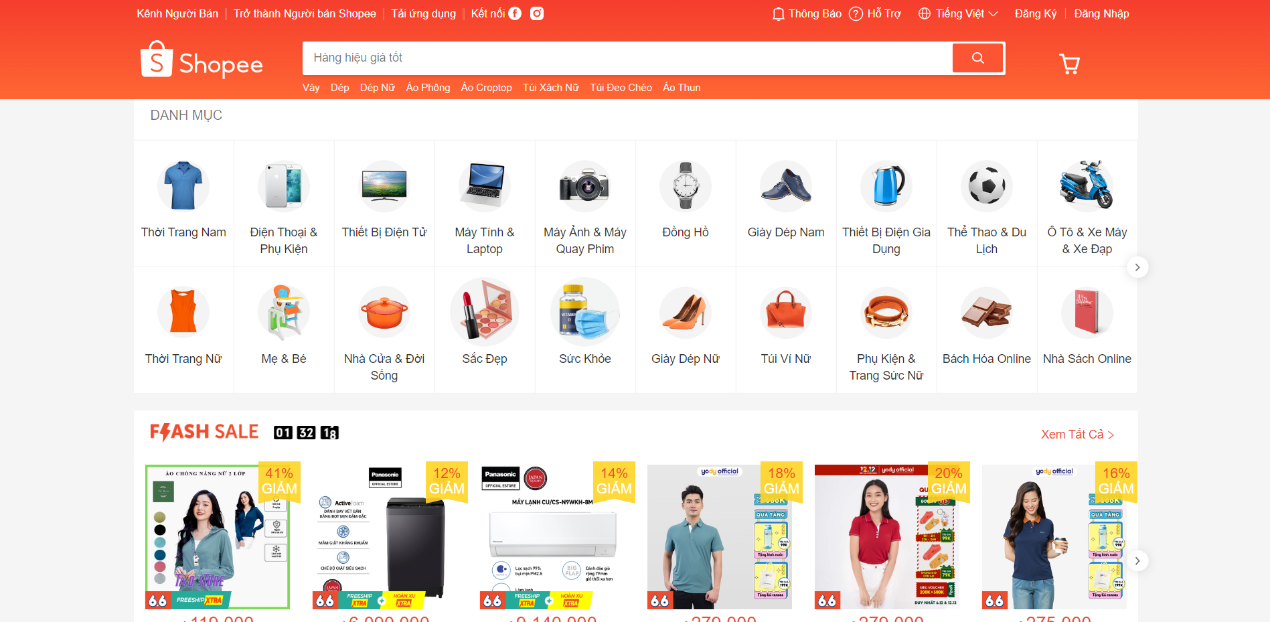

Figure 1: Shoppee Index UI

Table 1:Advantages and disadvantages of Shopee

|  |  |
| --- | --- |
| **Advantages and Disadvantages of Shopee** | |
| Advantages | * Fast access speed, making it easy to use * Beautiful interface, easy to see * Support online with the connection of online chat box from the buyer to seller * Location of functions that are simple to use and implement * In the process of clicking to examine product information, there is reasonable navigation. * The webpage completely introduces the website's material (introduction, policy, cooperation-affiliation).. * Compatible with many types of screens such as laptops, tablets, smartphones. |
| **Disadvantages** | * Too many advertisements. |

#### 2.1.2.2. Amazon

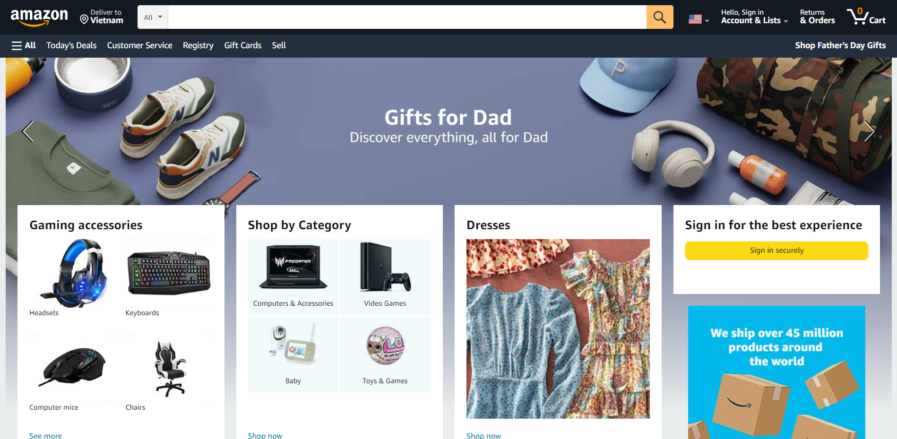

Figure 2: Amazon Index UI

Table 2: Advantages and Disadvantages of Amazon

|  |  |
| --- | --- |
| **Advantages and disadvantages of Amazon** | |
| **Advantages** | * Support multi-languages * The interface is simple but suitable and comfortable. * Location of functions that are easy to access, easy to implement * Reasonable navigation in the process of clicking to view product details * The website fully introduces the information of the website (introduction, policy, cooperation-affiliation) * Compatible with many types of screens such as laptops, tablets, smartphones. |
| **Disadvantages** | * Only accept paypal and master card as payment method |

#### 2.1.2.3. Alibaba

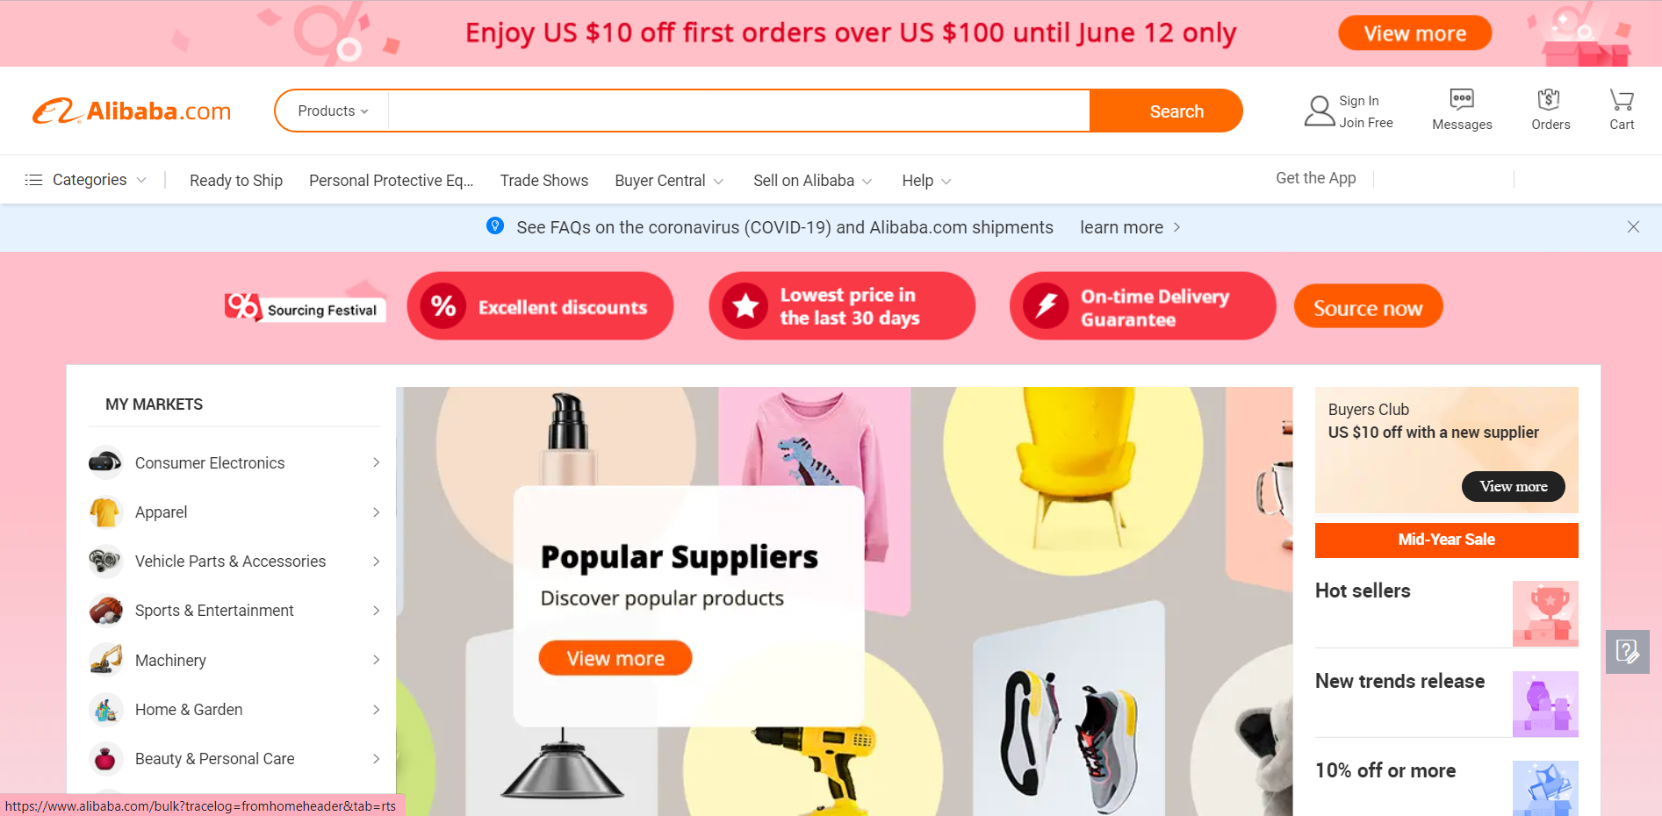

Figure 3: Alibaba Index UI

Table 3: Advantages and disadvantages of Alibaba

|  |  |
| --- | --- |
| Advantages and Disadvantages of Alibaba | |
| **Advantages** | * Have a list of frequently asked Questions. * Location of functions that are easy to access, easy to implement. * Reasonable navigation in the process of clicking to view product details. * The website fully introduces the information of the website (introduction, policy, cooperation-affiliation). * Compatible with many types of screens such as laptops, tablets, smart phones. * Support chat-box. * Certificate of completion of the course |
| **Disadvantages** | * Do not support multi language. |

## 2.2. Functional Requirements

### 2.2.1. Authorization

Table 4: Authorization

|  |  |  |
| --- | --- | --- |
| **No** | **Actor** | **Description** |
| 1 | Admin |  |
| 2 | Customer | Users already have an account on this application |
| 3 | Shipper |  |
| 4 | Guest | The user does not have an account |

### 2.2.2. System’s operations

Table 5: System’s operations

|  |  |  |
| --- | --- | --- |
| **Ord** | **Function** | **Description** |
| 1 | Register/Login | Customer creates new account/ login to website. |
| 2 | Forgot Password | Customer forgot password and want to get password again. |
| 3 | Manage account information | Admin can add, update, delete the user information. |
| 4 | Manage accounts | Admin can view and ban accounts. |
| 5 | Call customer for order confirmation | Admin can call customers to ask them for order confirm. |
| 6 | Manage products | Admin can add, update, remove product information. |
| 7 | View all products | Admim, guest and customer can see the product list. |
| 8 | View all invoices | Admin can see all invoices and filter them. customer can only see his/her invoice history, shipper can see and accept invoices to delivery. |
| 9 | View all users | Admin can see the users list. |
| 10 | Choose payment method | Customer can choose a payment method. |
| 11 | Rate products | Customer can rate products. |
| 12 | Comment products | Customer can comment about products. |
| 13 | Manage cart | Customer can add, update, delete products from cart. |
| 14 | Order acceptance | Admin can accept or refuse COD orders, shipper can accept invoice to delivery. |
| 15 | Delivery report | Shipper can report delivery status to the system. |
| 16 | Cancel order | Customer can cancel COD order only when waiting for admin acceptance. |
| 17 | Refund | Admin can refund customer when an order is canceled validly. |

## 2.3. Non-functional Requirements

* User-friendly interface
* Process data as quick as possible
* Guarantee customer personal information security
* Easy to maintain and develop in the future
* High integrity for customers

# Chapter 3: Theory Fundamental

## 3.1. System architecture

We use HTML/CSS and Javascript to develop application UI, then we use Thymeleaf as a mean of Front-end and Back-end communication, then JAVA Spring Boot will handle data and some logical events before making any update on MySQL database

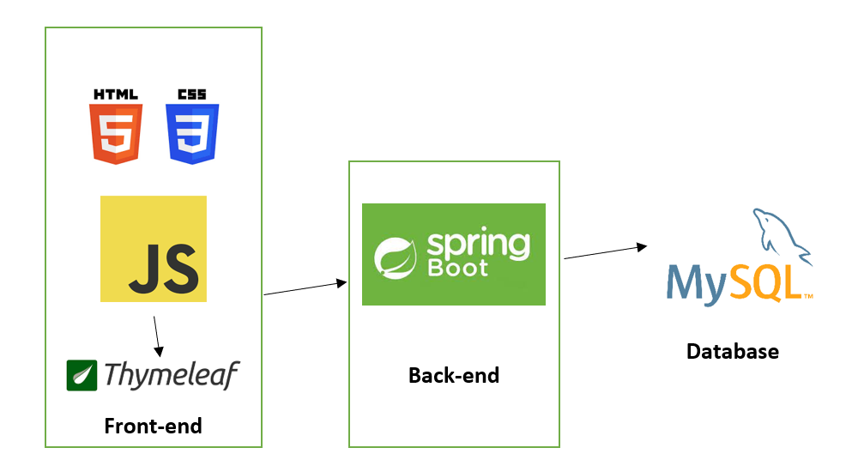

Figure 4: System Structure

## 3.2. Libraries

### 3.2.1. Back-end

Table 6: Back-end libraries

|  |  |  |
| --- | --- | --- |
| **Library** | **Version** | **Purposes** |
| Joi | 17.1.1 | check the logic of variables |
| Cloudinary | 2.1 | is an extension of joi support date |
| Paypal |  | Payment |
| Momo |  | Payment |
| Moment | 2.24.0 | interact with date |
| Multer | 2.4.3 | bcrypt encryption |
| Mongoose | 1.19.0 | parse request of body |
| Cors | 2.8.5 | collaboration with cors |
| cross-env | 7.0.0 | flexibly change environment variables |
| Express | 4.17.1 | framework of web app |
| Mongodb | 4.1.3 | Connect to database MongoDB |
| Mongoose | 5.13.12 | Connect to database MongoDB |
| Multer | 1.4.3 | allow sending files to the server |
| Cloudinary | 1.28.1 | Connect to Cloudinary image storage service |

### 3.2.2. Front-end

Table 7: Front-end libraries

|  |  |  |
| --- | --- | --- |
| **Library** | **Version** | **Purposes** |
| Joi | 17.1.1 | check the logic of variables |
| Cloudinary | 2.1 | is an extension of joi support date |
| Paypal |  | Payment |
| Momo |  | Payment |
| Moment | 2.24.0 | interact with date |
| Multer | 2.4.3 | bcrypt encryption |
| Mongoose | 1.19.0 | parse request of body |
| Cors | 2.8.5 | collaboration with cors |
| cross-env | 7.0.0 | flexibly change environment variables |
| Express | 4.17.1 | framework of web app |
| Mongodb | 4.1.3 | Connect to database MongoDB |
| Mongoose | 5.13.12 | Connect to database MongoDB |
| Multer | 1.4.3 | allow sending files to the server |
| Cloudinary | 1.28.1 | Connect to Cloudinary image storage service |

## 3.2. Technology

### 3.2.1. Thymeleaf

Thymeleaf is a server-side Java-based template engine for both web and standalone environments, capable of processing HTML, XML, JavaScript, CSS and even plain text. It is more powerful than JPS and responsible for dynamic content rendering on UI.

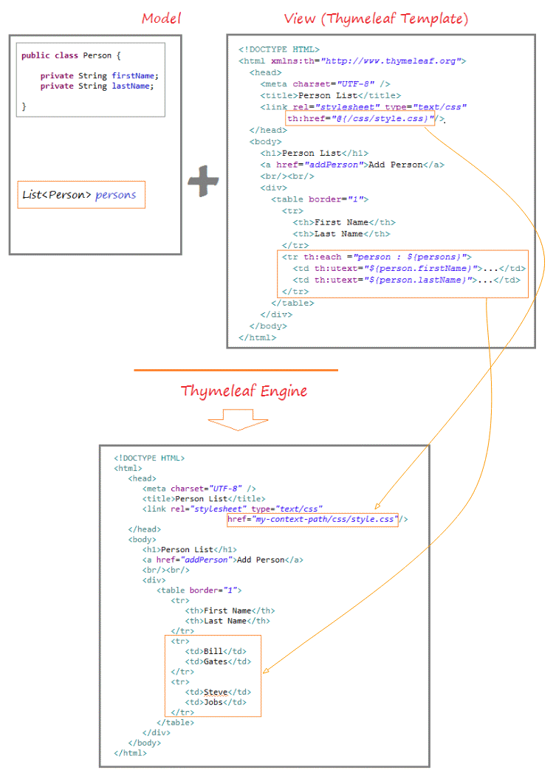

Figure 5: How Thymeleaf works

### 3.2.2. JAVA Spring Boot

Java Spring Framework (Spring Framework) is a popular, open source, enterprise-level framework for creating standalone, production-grade applications that run on the Java Virtual Machine (JVM).

Java Spring Boot (Spring Boot) is a tool that makes developing web application and microservices with Spring Framework faster and easier through three core capabilities:

* Autoconfiguration
* An opinionated approach to configuration
* The ability to create standalone applications

### 3.2.3. MySQL

MySQL is a fast, easy-to-use RDBMS being used for many small and big businesses. MySQL is developed, marketed and supported by MySQL AB, which is a Swedish company. There are good reasons making it become so popular:

* MySQL is released under an open-source license. So you have nothing to pay to use it.
* MySQL is a very powerful program in its own right. It handles a large subset of the functionality of the most expensive and powerful database packages.
* MySQL uses a standard form of the well-known SQL data language.
* MySQL works on many operating systems and with many languages including PHP, PERL, C, C++, JAVA, etc.
* MySQL works very quickly and works well even with large data sets.
* MySQL is very friendly to PHP, the most appreciated language for web development.
* MySQL supports large databases, up to 50 million rows or more in a table. The default file size limit for a table is 4GB, but you can increase this (if your operating system can handle it) to a theoretical limit of 8 million terabytes (TB).
* MySQL is customizable. The open-source GPL license allows programmers to modify the MySQL software to fit their own specific environments.

# Chapter 4: System Design

## 4.1. Use case diagrams

### 4.1.1. Login

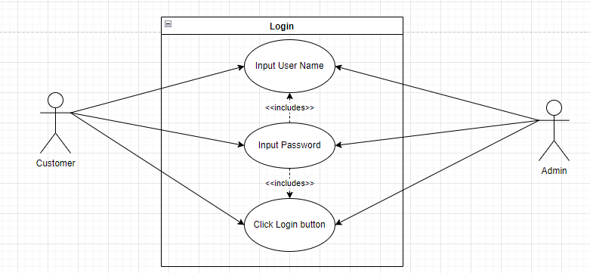

Figure 6: Login usecase

Table 8: Usecase login

|  |  |
| --- | --- |
| **Name** | Log In |
| **Brief Description** | The way user website logins |
| **Actor(s)** | All user login into system |
| **Flow of Events** | |
| **Basic Flow** | |
| This use case starts when the user wants to access the system   1. User select “Login” function on the system 2. The system displays the Login page 3. User enter the correct username and password then click "Log in" 4. The system will return the user to Home page. | |
| **Alternate Flows** | |
| **Title** | **Description** |
| Enter the wrong login information | 1.  If the user enters an invalid password, the system will announce the username or password is invalid and ask the user to re-enter the password. |
| **Pre-Conditions** | |
| **Title** | **Description** |
|  | The user already has an account on the system |
| **Post-Conditions** | |
| **Title** | **Description** |
| Success | Log in successfully, the user accesses the system. |
| Failure | Login failed, the user cannot log in. |
| **Extension Points** | |
| None | |

### 4.1.2. Register

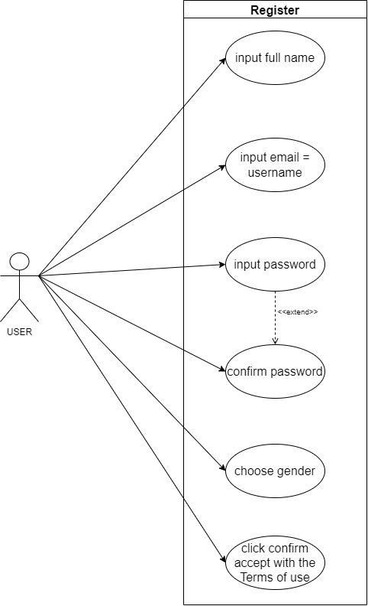

Figure 7: Register usecase

Table 9: Register usecase

|  |  |
| --- | --- |
| **Name** | Register |
| **Brief Description** | The way customer creates personal account |
| **Actor(s)** | User |
| **Flow of Events** | |
| **Basic Flow** | |
| This use case starts when the user chooses the function to register   1. User chooses the "Register" function in the system. 2. The system displays a Register page with information about username, password, phone number, email, address, … 3. Customer fills out the above information and presses the "Register" button .    4. The notification system has successfully registered. | |
| **Alternate Flows** | |
| **Title** | **Description** |
| Fill out the information missing | 1. The system requires re-fill and full information in the "Register" page. |
| **Pre-Conditions** | |
| **Title** | **Description** |
| Failed | Account has already existed in the system |
| **Post-Conditions** | |
| **Title** | **Description** |
| Success | Register successfully, user create account successfully. |
| Failure | Register failed, user created account failure. |
| **Extension Points** | |

### 4.1.3. Forgot password

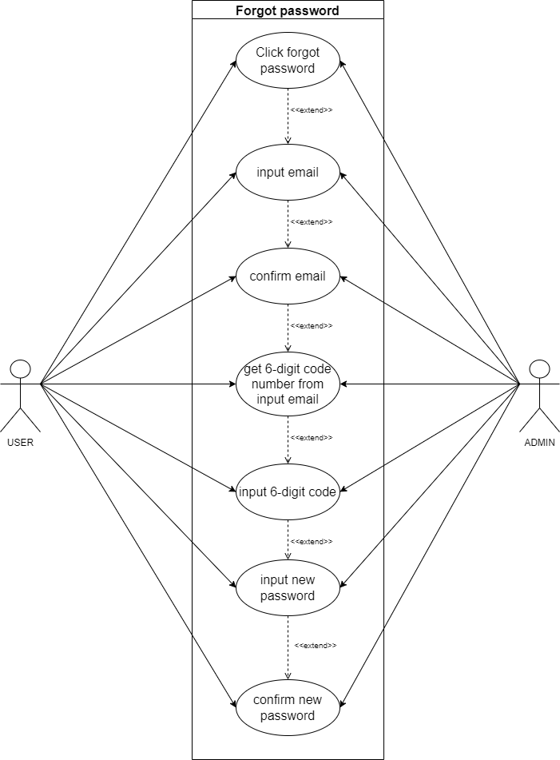

Figure 8: Forgot password usecase

Table 10: Forgot password usecase

|  |  |
| --- | --- |
| **Name** | Forgot password |
| **Brief Description** | The way user can get an temporary password from email sent by system to log in to system |
| **Actor(s)** | All kinds of users |
| **Flow of Events** | |
| **Basic Flow** | |
| This use case starts when the user chooses the function forgot password   1. User chooses the "Forgot password" function in the system. 2. The system will send you an email that gives you a random password for you to log in to the system | |
| **Alternate Flows** | |
| **Title** | **Description** |
| Fill out the information missing | 1. The system requires re-fill username at the "Login" page. |
| **Pre-Conditions** | |
| **Title** | **Description** |
| Failed | Can not send mail |
| **Post-Conditions** | |
| **Title** | **Description** |
| Success | Send mail successfully |
| Failure | Send mail failed |
| **Extension Points** | |

### 4.1.4. Change profile information

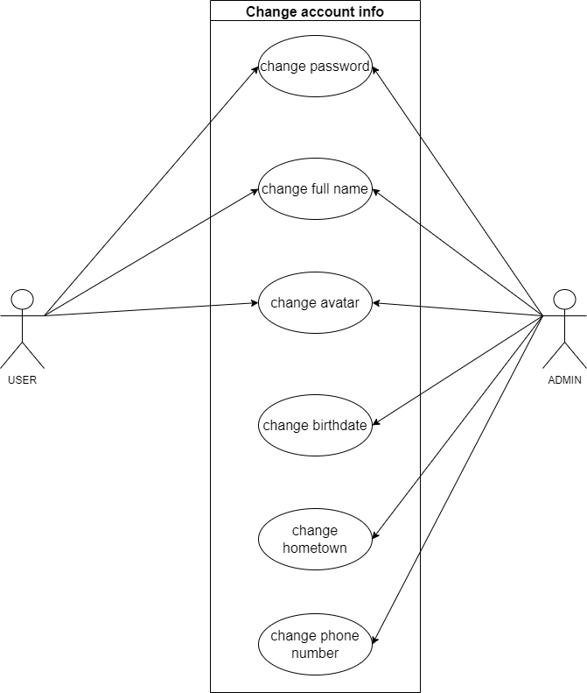

Figure 9: Change profile usecase

Table 11: Change profile information usecase

|  |  |
| --- | --- |
| **Name** | Change profile information |
| **Brief Description** | User changes personal profile |
| **Actor(s)** | Customer |
| **Flow of Events** | |
| **Basic Flow** | |
| This use case starts when the user wants to edit profile   1. User fill in text boxes 2. Click Edit button | |
| **Alternate Flows** | |
| **Title** | **Description** |
| Fill out the information missing | 1. The system requires re-fill empty text box at the “Profile page”. |
| **Pre-Conditions** | |
| **Title** | **Description** |
| Logged in | Must be logged in |
| **Post-Conditions** | |
| **Title** | **Description** |
| Success | Edit successfully |
| Failure | Edit failed |
| **Extension Points** | |

### 4.1.5. Add to cart

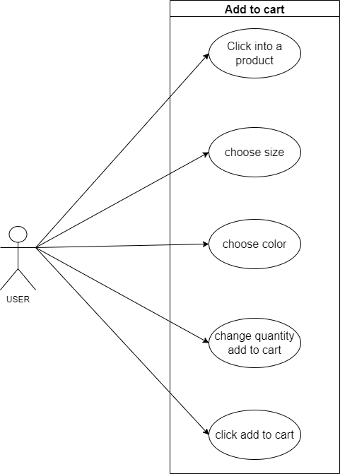

Figure 10: Add to cart usecase

Table 12: Add to cart usecase

|  |  |
| --- | --- |
| **Name** | Add to cart |
| **Brief Description** | User add a product to cart |
| **Actor(s)** | Customer |
| **Flow of Events** | |
| **Basic Flow** | |
| This use case starts when the user chooses the function Add to cart   1. User choose size, quantity and color 2. Click Add to cart button | |
| **Alternate Flows** | |
| **Title** | **Description** |
| Fill out the information missing | 1. The system requires re-fill empty size checkbox at the “Product details page”. |
| **Pre-Conditions** | |
| **Title** | **Description** |
| Logged in | Must be logged in |
| **Post-Conditions** | |
| **Title** | **Description** |
| Success | Add successfully |
| Failure | Add failed |
| **Extension Points** | |

### 4.1.6. Remove from cart

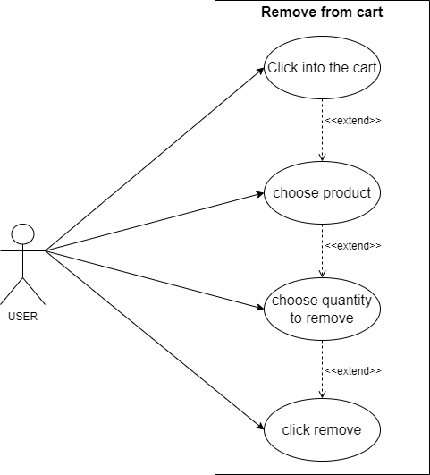

Figure 11: Remove from cart usecase

Table 13: Remove from cart usecase

|  |  |
| --- | --- |
| **Name** | Remove from cart |
| **Brief Description** | User remove a product from cart |
| **Actor(s)** | Customer |
| **Flow of Events** | |
| **Basic Flow** | |
| This use case starts when the user chooses the function Add to cart   1. Select product to remove 2. Click “X” button | |
| **Alternate Flows** | |
| **Title** | **Description** |
|  |  |
| **Pre-Conditions** | |
| **Title** | **Description** |
| Logged in | Must be logged in |
| **Post-Conditions** | |
| **Title** | **Description** |
| Success | Remove successfully |
| Failure | Remove failed |
| **Extension Points** | |

### 4.1.7. Choose from cart to buy

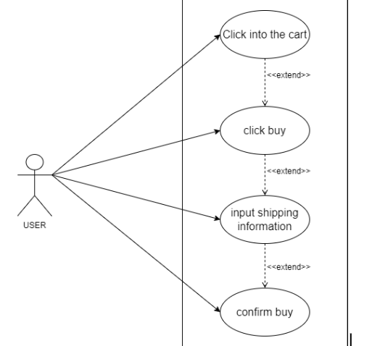

Figure 12: Choose from cart to buy usecase

Table 14: Choose from cart to buy usecase

|  |  |
| --- | --- |
| **Name** | Select products from cart to buy |
| **Brief Description** | User choose products from cart |
| **Actor(s)** | Customer |
| **Flow of Events** | |
| **Basic Flow** | |
| This use case starts when the user chooses products from cart to buy   1. Select product to buy 2. Click “Update cart” button 3. Click “Proceed to checkout” button | |
| **Alternate Flows** | |
| **Title** | **Description** |
| Forget clicking Update cart before clicking Proceed to checkout | Check out render information of cart before clicking Update cart |
| **Pre-Conditions** | |
| **Title** | **Description** |
| Logged in | Must be logged in |
| **Post-Conditions** | |
| **Title** | **Description** |
| Success | Render cart information as expected |
| Failure | Render cart information not as expected |
| **Extension Points** | |

### 4.1.8. Cancel order when waiting admin to confirm the order

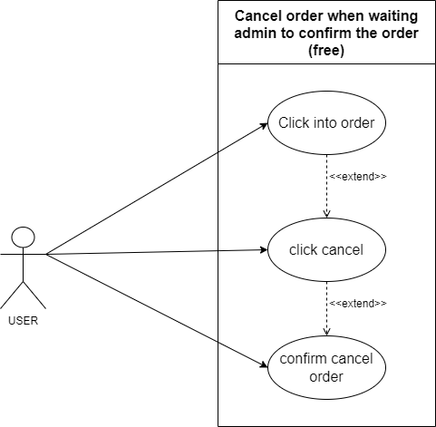

Figure 13: Cancel order when waiting for admin to confirm the order usecase

Table 15: Cancel order when waiting admin to confirm the order usecase

|  |  |
| --- | --- |
| **Name** | Cancel order when waiting admin to confirm the order |
| **Brief Description** | Customer cancel order |
| **Actor(s)** | Customer |
| **Flow of Events** | |
| **Basic Flow** | |
| This use case starts when the user cancel an order   1. Move to Purchase History 2. Click “Cancel” button at the order you want to cancel | |
| **Alternate Flows** | |
| **Title** | **Description** |
| Forget clicking Update cart before clicking Proceed to checkout | Check out render information of cart before clicking Update cart |
| **Pre-Conditions** | |
| **Title** | **Description** |
| Logged in | Must be logged in |
| **Post-Conditions** | |
| **Title** | **Description** |
| Success | Cancel successfully |
| Failure | Cancel failed |
| **Extension Points** | |

### 4.1.9. Search product

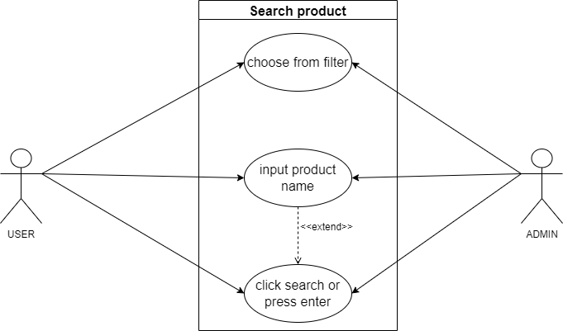

Figure 14: Search product usecase

Table 16: Search product usecase

|  |  |
| --- | --- |
| **Name** | Search product |
| **Brief Description** | Customer search for product |
| **Actor(s)** | Customer |
| **Flow of Events** | |
| **Basic Flow** | |
| This use case starts when the user cancel an order   1. Move to Shop products page 2. Click into search bar 3. Input product name 4. Click “Search” | |
| **Alternate Flows** | |
| **Title** | **Description** |
| Forget clicking Update cart before clicking Proceed to checkout | Check out render information of cart before clicking Update cart |
| **Pre-Conditions** | |
| **Title** | **Description** |
| Logged in | Must be logged in |
| **Post-Conditions** | |
| **Title** | **Description** |
| Success | Cancel successfully |
| Failure | Cancel failed |
| **Extension Points** | |

### 4.1.10. Rating product

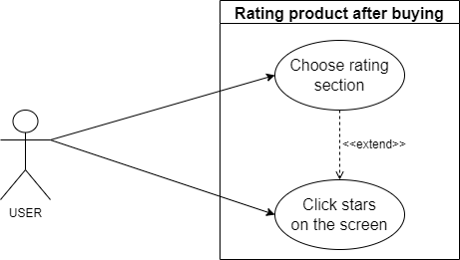

Figure 15: Rating product usecase

Table 17: Rating product usecase

|  |  |
| --- | --- |
| **Name** | Rate product |
| **Brief Description** | Customer rate for product |
| **Actor(s)** | Customer |
| **Flow of Events** | |
| **Basic Flow** | |
| This use case starts when the user rate a product   1. Move to Product details page 2. Click into rating stars bar 3. Click on star you want to rate 4. Confirm rating | |
| **Alternate Flows** | |
| **Title** | **Description** |
| Forgot loggin in | System auto redirect to login page |
| **Pre-Conditions** | |
| **Title** | **Description** |
| Logged in | Must be logged in |
| **Post-Conditions** | |
| **Title** | **Description** |
| Success | Rate successfully |
| Failure | Rate failed |
| **Extension Points** | |

### 4.1.11. Comment product

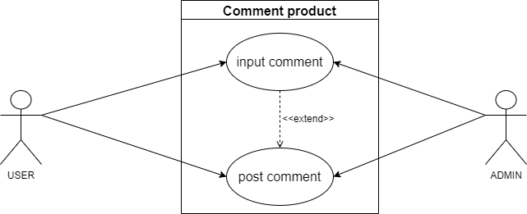

Figure 16: Comment product usecase

Table 18: Comment product usecase

|  |  |
| --- | --- |
| **Name** | Comment |
| **Brief Description** | The way user comment in product reviews |
| **Actor(s)** | All customer login into system |
| **Flow of Events** | |
| **Basic Flow** | |
| This use case starts when the user wants to comment product   1. User select product from shop page 2. User enter the comment 3. Click post | |
| **Alternate Flows** | |
| **Title** | **Description** |
| Fill out information missing | User click Post button with empty comment textbox |
| **Pre-Conditions** | |
| **Title** | **Description** |
|  | The user already has an account on the system |
| **Post-Conditions** | |
| **Title** | **Description** |
| Success | Post successfully. |
| Failure | Post failed. |
| **Extension Points** | |
| None | |

### 4.1.10. Add product

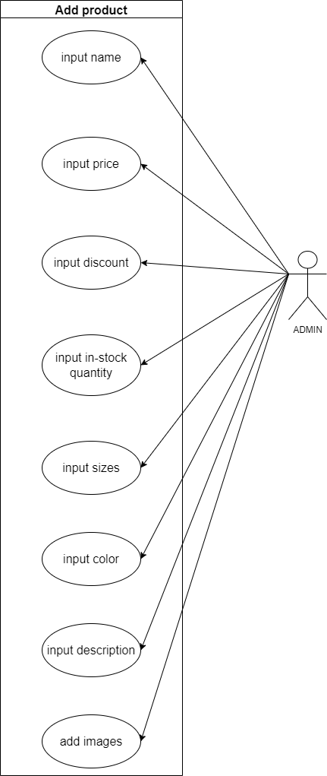

Figure 17: Add product usecase

Table 19: Add product usecase

|  |  |
| --- | --- |
| **Name** | Add product |
| **Brief Description** | The way admin add new product to shop |
| **Actor(s)** | Just admin into system |
| **Flow of Events** | |
| **Basic Flow** | |
| This use case starts when the admin wants to add new product   1. Admin click in “Add new product” in Product Management 2. Admin fill in all information textbox of product 3. Click add | |
| **Alternate Flows** | |
| **Title** | **Description** |
| Fill out information missing | Admin click add button with empty information textbox |
| **Pre-Conditions** | |
| **Title** | **Description** |
|  | The admin already has an account on the system |
| **Post-Conditions** | |
| **Title** | **Description** |
| Success | Add new product successfully. |
| Failure | Add new product failed. |
| **Extension Points** | |
| None | |

### 4.1.11. Delete product

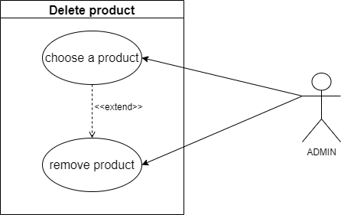

Figure 18: Delete product usecase

Table 20: Delete product usecase

|  |  |
| --- | --- |
| **Name** | Delete product |
| **Brief Description** | The way admin delete product from shop |
| **Actor(s)** | Just admin into system |
| **Flow of Events** | |
| **Basic Flow** | |
| This use case starts when the admin wants to add new product   1. Choose product from product management 2. Admin click in “Delete product” button | |
| **Alternate Flows** | |
| **Title** | **Description** |
|  |  |
| **Pre-Conditions** | |
| **Title** | **Description** |
| Must be logged in | The admin already has an account on the system |
| **Post-Conditions** | |
| **Title** | **Description** |
| Success | Delete product successfully. |
| Failure | Delete product failed. |
| **Extension Points** | |
| None | |

### 4.1.12. Edit product

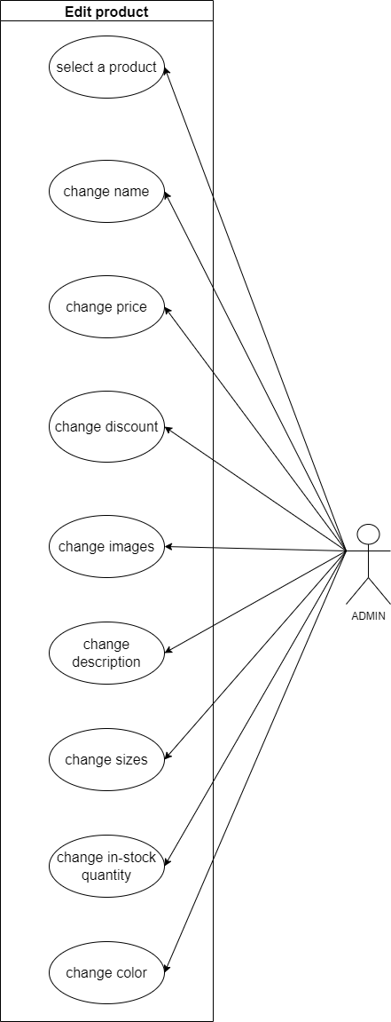

Figure 19: Edit product usecase

Table 21: Edit product usecase

|  |  |
| --- | --- |
| **Name** | Edit product |
| **Brief Description** | The way admin edit product from shop |
| **Actor(s)** | Just admin into system |
| **Flow of Events** | |
| **Basic Flow** | |
| This use case starts when the admin wants to edit new product   1. Choose product from product management 2. Admin click in “Edit product” button | |
| **Alternate Flows** | |
| **Title** | **Description** |
| Fill out information missing | Admin click add button with empty information textbox |
| **Pre-Conditions** | |
| **Title** | **Description** |
| Must be logged in | The admin already has an account on the system |
| **Post-Conditions** | |
| **Title** | **Description** |
| Success | Edit product successfully. |
| Failure | Edit product failed. |
| **Extension Points** | |
| None | |

### 4.1.13. Accept/Decline order (admin)

Figure 20: Accept/Decline order (admin) usecase

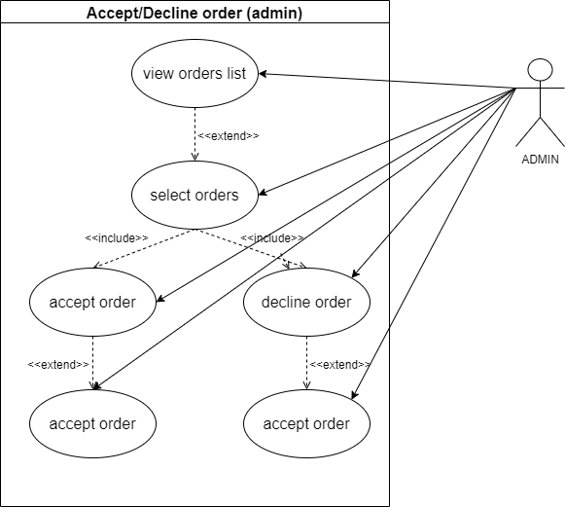

Table 22: Accept/Decline order (admin) usecase

|  |  |
| --- | --- |
| **Name** | Accept/Decline product |
| **Brief Description** | The way admin accept/decline product from shop |
| **Actor(s)** | Just admin into system |
| **Flow of Events** | |
| **Basic Flow** | |
| This use case starts when the admin wants to accept/decline new product   1. Choose product from product management 2. Admin click in accept/decline button | |
| **Alternate Flows** | |
| **Title** | **Description** |
|  |  |
| **Pre-Conditions** | |
| **Title** | **Description** |
| Must be logged in | The admin already has an account on the system |
| **Post-Conditions** | |
| **Title** | **Description** |
| Success | Accept/decline product successfully. |
| Failure | Accept/decline product failed. |
| **Extension Points** | |
| None | |

### 4.1.14. Accept order (shipper)

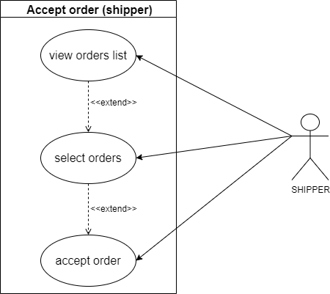

Figure 21: Accept order (shipper) usecase

Table 23: Accept order (shipper) usecase

|  |  |
| --- | --- |
| **Name** | Accept order |
| **Brief Description** | The way shipper accept order |
| **Actor(s)** | Just shipper in system |
| **Flow of Events** | |
| **Basic Flow** | |
| This use case starts when the admin wants to accept order   1. Choose order from shipper home 2. Shipper click in “Accept” order | |
| **Alternate Flows** | |
| **Title** | **Description** |
| Order is canceled by user | User canceled order at the same time while shipper accepting this order |
| **Pre-Conditions** | |
| **Title** | **Description** |
| Must be logged in | The shipper already has an account on the system |
| **Post-Conditions** | |
| **Title** | **Description** |
| Success | Accept order successfully. |
| Failure | Accept order failed. |
| **Extension Points** | |
| None | |

### 4.1.15. Confirm shipped order

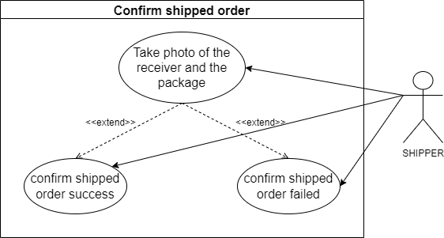

Figure 22: Confirm shipped order usecase

Table 24: Confirm shipped order usecase

|  |  |
| --- | --- |
| **Name** | Confirm shipped order |
| **Brief Description** | The way shipper confirm shipper order |
| **Actor(s)** | Just shipper into system |
| **Flow of Events** | |
| **Basic Flow** | |
| This use case starts when the admin wants to confirm shipped order   1. Choose order from delivery report 2. Click in look up icon | |
| **Alternate Flows** | |
| **Title** | **Description** |
|  |  |
| **Pre-Conditions** | |
| **Title** | **Description** |
| Must be logged in | The shipper already has an account on the system |
| **Post-Conditions** | |
| **Title** | **Description** |
| Success | Confirm shipped order successfully. |
| Failure | Confirm shipped order failed. |
| **Extension Points** | |
| None | |

### 4.1.16. Report problem

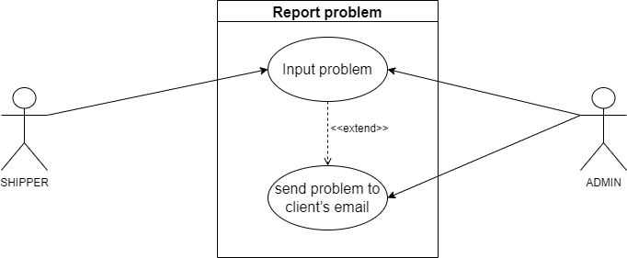

Figure 23: Report problem usecase

Table 25: Report problem usecase

|  |  |
| --- | --- |
| **Name** | Report delivery problem |
| **Brief Description** | The way shipper report delivery status |
| **Actor(s)** | Shipper |
| **Flow of Events** | |
| **Basic Flow** | |
| This use case starts when the admin wants to report delivery status   1. Choose order from shipping invoices 2. Click in look up icon 3. Choose given delivery status radio button 4. Take a picture as a proof 5. Click “Confirm” | |
| **Alternate Flows** | |
| **Title** | **Description** |
| Forgot taking a proof photo | Announce to take photo as a proof |
| **Pre-Conditions** | |
| **Title** | **Description** |
| Must be logged in | The shipper already has an account on the system |
| **Post-Conditions** | |
| **Title** | **Description** |
| Success | Confirm report successfully. |
| Failure | Confirm report failed. |
| **Extension Points** | |
| None | |

## 4.2. Sequence diagrams

### 4.2.1. Login

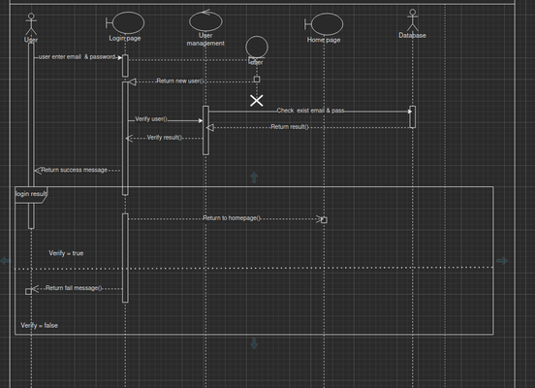

Figure 24: Login sequence

### 4.2.2. Register

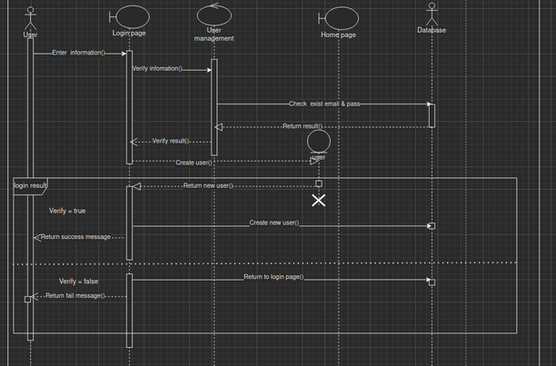

Figure 25: Register sequence

### 4.2.3. Forgot password

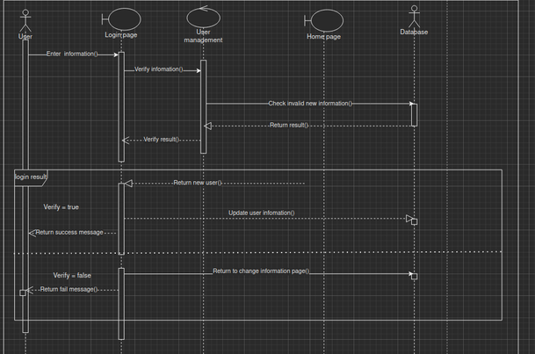

Figure 26: Forgot password sequence

### 4.2.4. Change profile information



Figure 27: Change profile information sequence

### 4.2.5. Add to cart

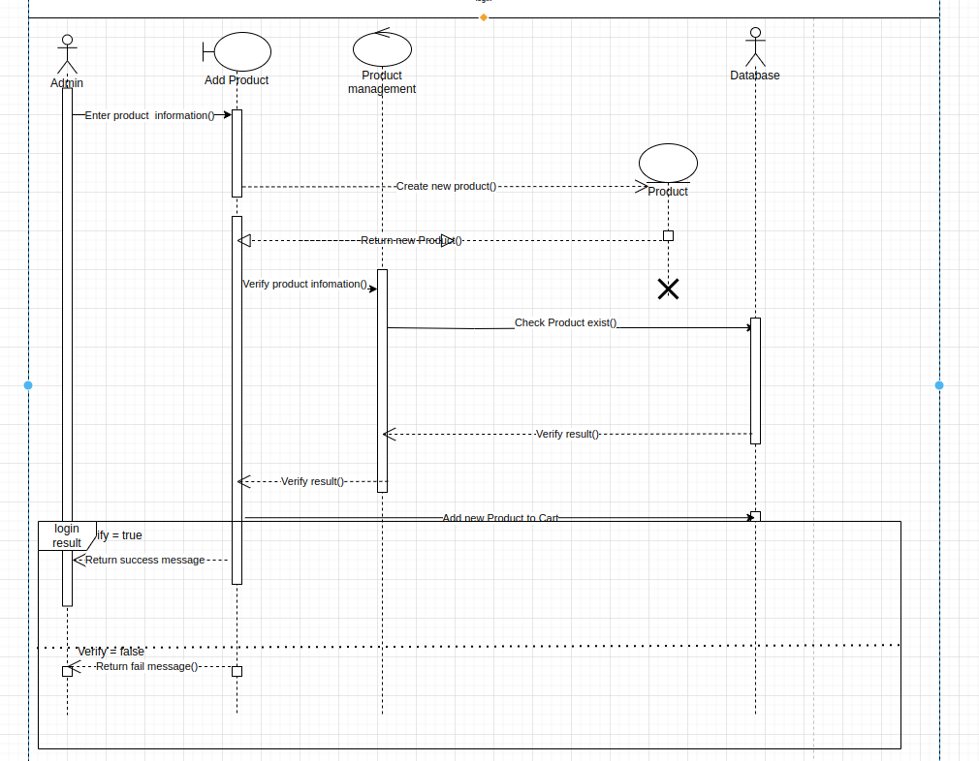

Figure 28: Add to cart sequence

### 4.2.6. Remove from cart

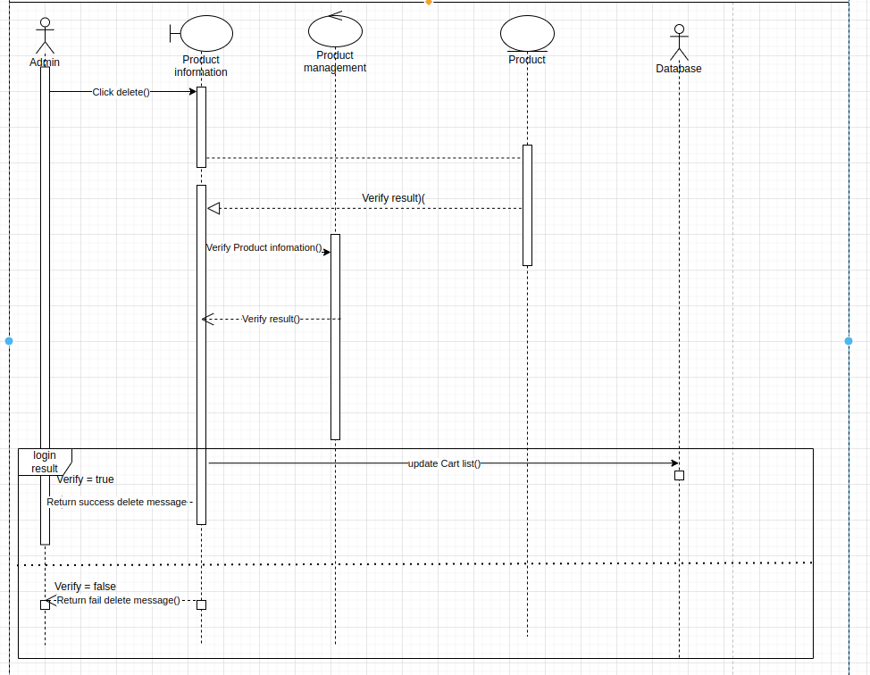

Figure 29: Remove from cart sequence

### 4.2.7. Choose from cart to buy

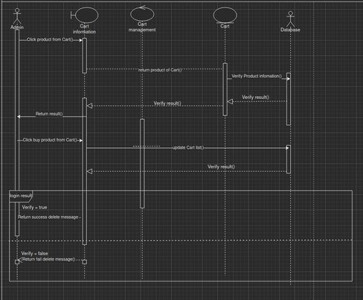

Figure 30: Choose from cart to buy sequence

### 4.2.8. Cancel order when waiting admin to confirm the order

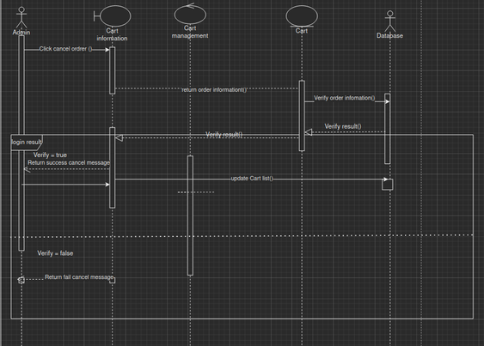

Figure 31: Cancel order when waiting admin to confirm the order sequence

### 4.2.9. Search product

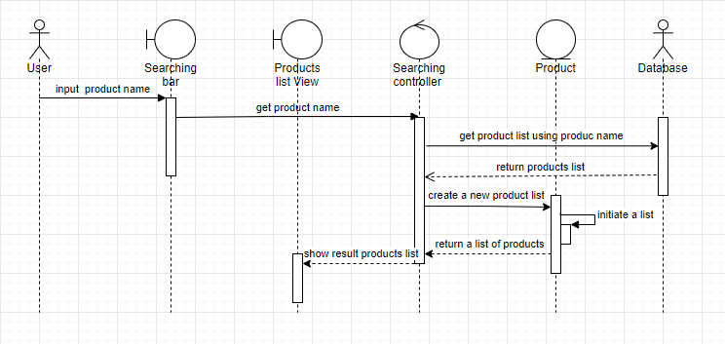

Figure 32: Search product sequence

### 4.2.10. Rating product

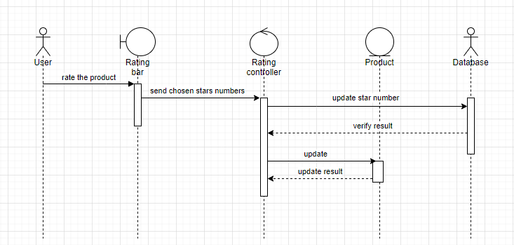

Figure 33: Rating product sequence

### 4.2.11. Comment product

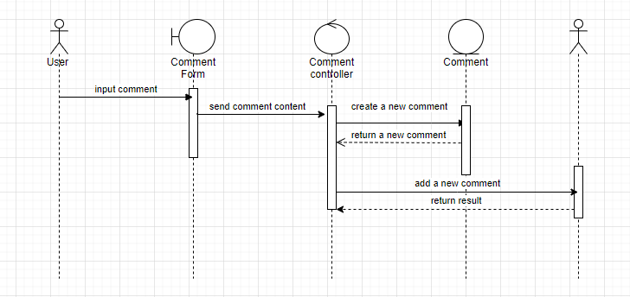

Figure 34: Comment product sequence

### 4.2.12. Add product

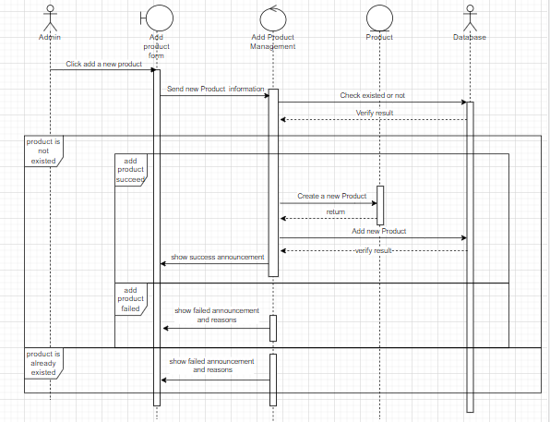

Figure 35: Add product sequence

### 4.2.13. Delete product

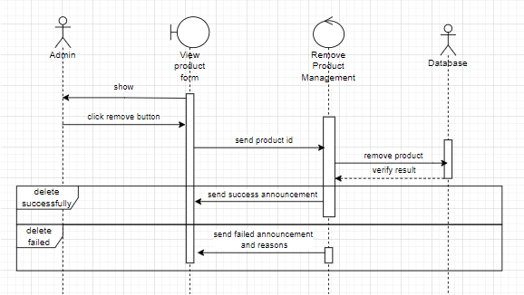

Figure 36: Delete product sequence

### 4.2.14. Edit product

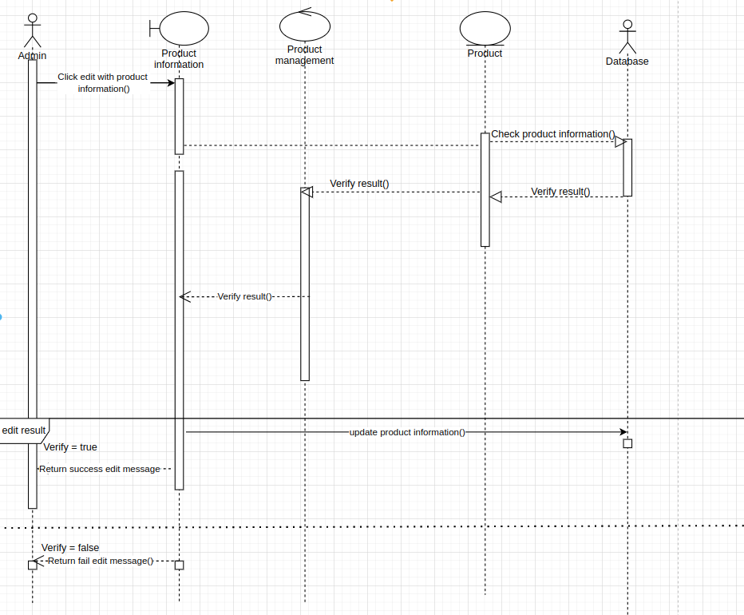

Figure 37: Edit product sequence

### 4.2.15. Accept/Decline order (admin)

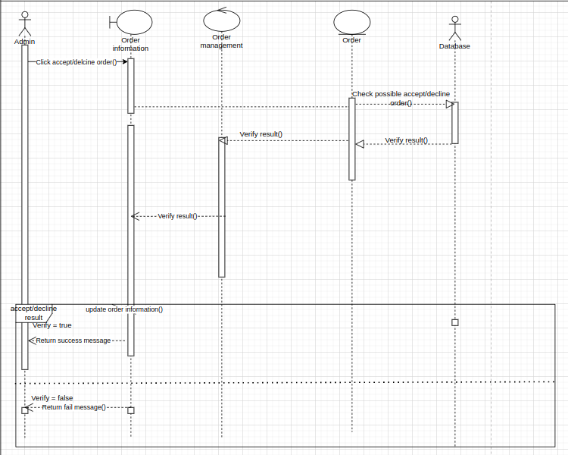

Figure 38: Accept/Decline order (admin) sequence

### 4.2.16. Accept order (shipper)

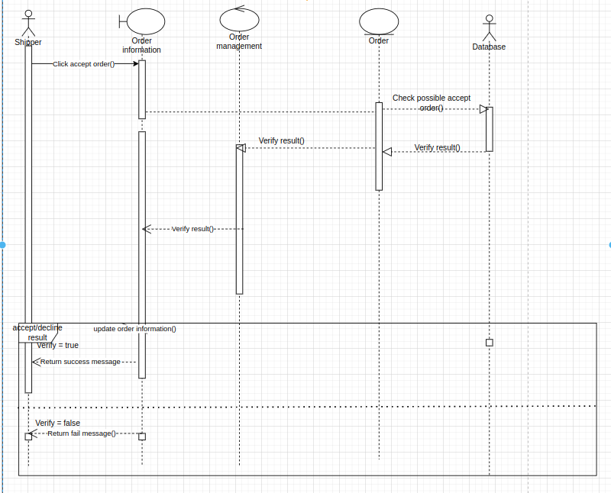

Figure 39: Accept order (shipper) sequence

### 4.2.17. Confirm shipped order

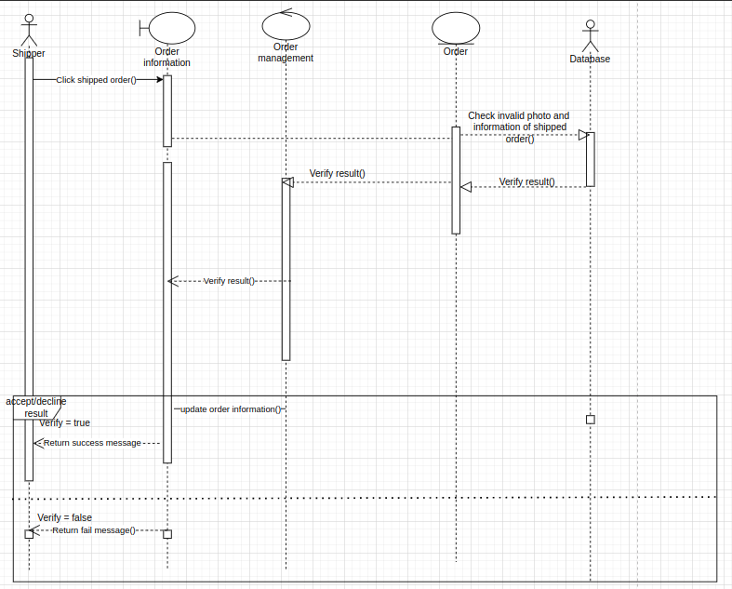

Figure 40: Confirm shipped order sequence

4.2.18. Report problem

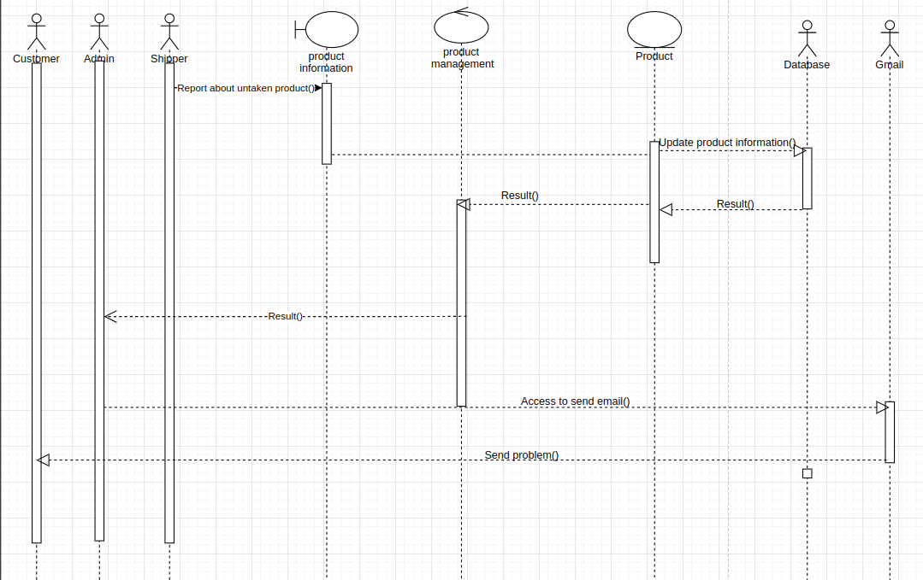

Figure 41: Report problem sequence

## 4.3. Database

### 4.3.1. ERD

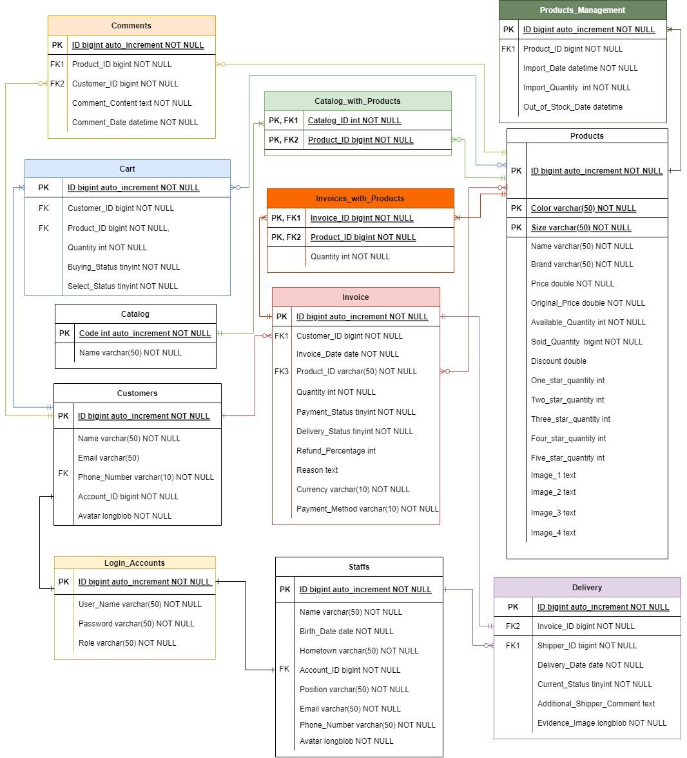

Figure 42: Database ERD

### 4.3.2. Class diagram

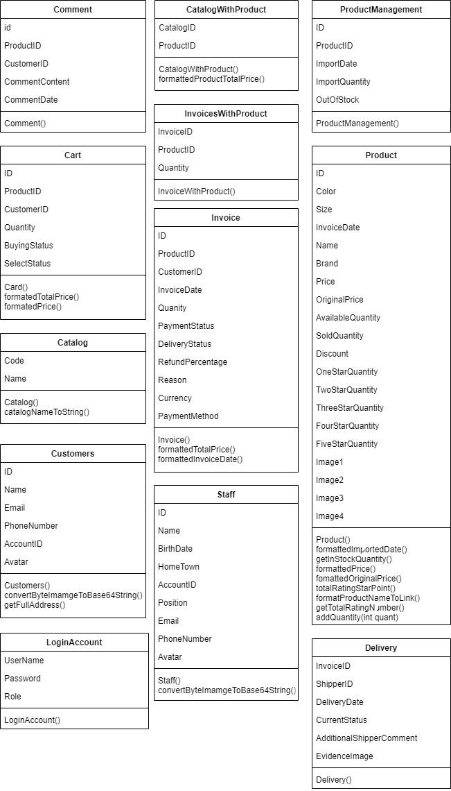

Figure 43: Database class diagram

### 4.3.3. Database table details

#### 4.3.3.1. Login_Accounts

Table 26: Login_Accounts table

|  |  |  |  |  |  |
| --- | --- | --- | --- | --- | --- |
| **ID** | **Attribute** | **Type** | **Range** | **Meaning** | **Notes** |
| 1 | ID | Bigint, auto_increment, not null | Primary key | Account ID |  |
| 2 | user_name | Varchar(50), not null |  | User Name of Account |  |
| 3 | password | Varchar(50), not null |  | Password of Account |  |
| 4 | role | Varchar(50), not null |  | Role of Account in system |  |

#### 4.3.3.2. Staffs

Table 27: Staffs table

|  |  |  |  |  |  |
| --- | --- | --- | --- | --- | --- |
| **ID** | **Attribute** | **Type** | **Range** | **Meaning** | **Notes** |
| 1 | ID | Bigint, auto_increment, not null | Primary key | Staff ID |  |
| 2 | name | Varchar(50), not null |  | Staff’s name |  |
| 3 | birth_date | Varchar(50), not null |  | Staff’s birth date |  |
| 4 | hometown | Varchar(50), not null |  | Staff’s hometown |  |
| 5 | account_id | Bigint, not null | Foreign key – reference to Login_Accounts | Staff’s account ID |  |
| 6 | position | Varchar(50), not null |  | Staff’s position |  |
| 7 | email | Varchar(50), not null |  | Staff’s email |  |
| 8 | phone_number | Varchar(50), not null |  | Staff’s phone number |  |
| 9 | avatar | Longblob, not null |  | Staff’s avatar |  |

#### 4.3.3.3. Delivery

Table 28: Delivery table

|  |  |  |  |  |  |
| --- | --- | --- | --- | --- | --- |
| **ID** | **Attribute** | **Type** | **Range** | **Meaning** | **Notes** |
| 1 | ID | Bigint, auto_increment, not null | Primary key | Staff ID |  |
| 2 | name | Varchar(50), not null |  | Staff’s name |  |
| 3 | birth_date | Varchar(50), not null |  | Staff’s birth date |  |
| 4 | hometown | Varchar(50), not null |  | Staff’s hometown |  |
| 5 | account_id | Bigint, not null | Foreign key – reference to Login_Accounts | Staff’s account ID |  |
| 6 | position | Varchar(50), not null |  | Staff’s position |  |
| 7 | email | Varchar(50), not null |  | Staff’s email |  |
| 8 | phone_number | Varchar(50), not null |  | Staff’s phone number |  |
| 9 | avatar | Longblob, not null |  | Staff’s avatar |  |

#### 4.3.3.4. Customers

Table 29: Customers table

|  |  |  |  |  |  |
| --- | --- | --- | --- | --- | --- |
| **ID** | **Attribute** | **Type** | **Range** | **Meaning** | **Notes** |
| 1 | ID | Bigint, auto_increment, not null | Primary key | Customer ID |  |
| 2 | name | Varchar(50), not null |  | Customer’s name |  |
| 3 | account_id | Bigint, not null | Foreign key – reference to Login_Accounts | Customer ‘s account ID |  |
| 4 | email | Varchar(50), not null |  | Customer’s email | Email format |
| 5 | phone_number | Varchar(50), not null |  | Customer’s phone number | Must be 10-digit |
| 6 | avatar | Longblob, not null |  | Customer’s avatar |  |

#### 4.3.3.5. Cart

Table 30: Cart table

|  |  |  |  |  |  |
| --- | --- | --- | --- | --- | --- |
| **ID** | **Attribute** | **Type** | **Range** | **Meaning** | **Notes** |
| 1 | ID | Bigint, auto_increment, not null | Primary key | Cart ID |  |
| 2 | customer_id | Bigint, not null | Foreign key – reference to Customers | Customer ID of Cart |  |
| 3 | product_id | Bigint, not null | Foreign key – reference to Products | Product ID in Cart |  |
| 4 | quantity | Int, not null |  | Quantity | Must be higher than 0 |
| 5 | buying_status | Tinyint, not null |  | Cart buy status |  |
| 6 | Select_status | Tinyint, not null |  | Cart select status |  |

#### 4.3.3.6. Products

Table 31: Products table

|  |  |  |  |  |  |
| --- | --- | --- | --- | --- | --- |
| **ID** | **Attribute** | **Type** | **Range** | **Meaning** | **Notes** |
| 1 | ID | Bigint, auto_increment, not null | Primary key | Product ID |  |
| 2 | color | Varchar(50), not null | Primary key | Product color |  |
| 3 | size | Varchar(50), not null | Primary key | Product size |  |
| 4 | name | Varchar(50), not null |  | Product name |  |
| 5 | brand | Varchar(50), not null |  | Product brand |  |
| 6 | price | Double, not null |  | Product price | Must be higher than 0 |
| 7 | original_price | Double, not null |  | Product original price | Must be higher than 0 and smaller than Price |
| 8 | available_quantity | Int, not null |  | Product available quantity |  |
| 9 | sold_quantity | Bigint, not null |  | Product sold quantity |  |
| 10 | discount | Double, not null |  | Product discount percentage |  |
| 11 | one_star_quantity | int |  | Product one-star rating quantity |  |
| 12 | two_star_quantity | int |  | Product two-star rating quantity |  |
| 13 | three_star_quantity | int |  | Product three-star rating quantity |  |
| 14 | four_star_quantity | int |  | Product four-star rating quantity |  |
| 15 | five_star_quantity | int |  | Product five-star rating quantity |  |
| 16 | image_1 | text |  | Product image 1 | URL of image |
| 17 | image_2 | text |  | Product image 2 | URL of image |
| 18 | image_3 | text |  | Product image 3 | URL of image |
| 19 | image_4 | text |  | Product image 4 | URL of image |

#### 4.3.4.7. Products_Management

Table 32: Products_Management table

|  |  |  |  |  |  |
| --- | --- | --- | --- | --- | --- |
| **ID** | **Attribute** | **Type** | **Range** | **Meaning** | **Notes** |
| 1 | ID | Bigint, auto_increment, not null | Primary key | Product Management ID |  |
| 2 | product_id | Bigint, not null | Foreign key – reference to Products | Product ID |  |
| 3 | import_date | Datetime, not null |  | Import date |  |
| 4 | import_quantity | Int, not null |  | Imported product quantity | Must be higher than 0 |
| 5 | out_of_stock_date | Datetime |  | Date that the product runs out of stock |  |

#### 4.3.4.8. Catalog_with_Products

Table 33: Catalog_with_Products table

|  |  |  |  |  |  |
| --- | --- | --- | --- | --- | --- |
| **ID** | **Attribute** | **Type** | **Range** | **Meaning** | **Notes** |
| 1 | catalog_id | Bigint, not null | Primary key, Foreign key – reference to Catalog | Catalog ID |  |
| 2 | product_id | Bigint, not null | Primary key, Foreign key – reference to Products | Product ID |  |

#### 4.3.4.9. Catalog

Table 34: Catalog table

|  |  |  |  |  |  |
| --- | --- | --- | --- | --- | --- |
| **ID** | **Attribute** | **Type** | **Range** | **Meaning** | **Notes** |
| 1 | ID | Bigint, auto_increment, not null | Primary key | Catalog ID |  |
| 2 | name | Varchar(50), not null |  | Catalog Name |  |

#### 4.3.4.10. Invoice

Table 35: Invoice table

|  |  |  |  |  |  |
| --- | --- | --- | --- | --- | --- |
| **ID** | **Attribute** | **Type** | **Range** | **Meaning** | **Notes** |
| 1 | ID | Bigint, auto_increment, not null | Primary key | Invoice ID |  |
| 2 | product_id | Bigint, not null | Foreign key – reference to Products | Product ID |  |
| 3 | customer_id | Bigint, not null |  | Customer ID |  |
| 4 | quantity | Int, not null |  | Product quantity | Must be higher than 0 |
| 5 | invoice_date | Datetime |  | Invoice date |  |
| 6 | payment_status | tinyint, not null |  | Payment status |  |
| 7 | delivery_status | tinyint, not null |  | Delivery status |  |
| 8 | refund_percentage | int |  | Refund percentage |  |
| 9 | reason | text |  | Reason for failed orders |  |
| 10 | currency | Varchar(10), not null |  | Currency used for payment |  |
| 11 | payment_method | Varchar(10), not null |  | Payment method |  |

#### 4.3.4.11. Invoices_with_Products

Table 36: Invoices_with_Products table

|  |  |  |  |  |  |
| --- | --- | --- | --- | --- | --- |
| **ID** | **Attribute** | **Type** | **Range** | **Meaning** | **Notes** |
| 1 | invoice_id | Bigint, not null | Primary key, Foreign key – reference to Invoice | Invoice ID |  |
| 2 | product_id | Bigint, not null | Primary key, Foreign key – reference to Products | Product ID |  |
| 3 | quantity | Int, not null |  | Product quantity | Must be higher than 0 |

#### 4.3.4.12. Comments

Table 37: Comments table

|  |  |  |  |  |  |
| --- | --- | --- | --- | --- | --- |
| **ID** | **Attribute** | **Type** | **Range** | **Meaning** | **Notes** |
| 1 | ID | Bigint, auto_increment ,not null | Primary key | Invoice ID |  |
| 2 | product_id | Bigint, not null | Primary key, Foreign key – reference to Products | Product ID |  |
| 3 | customer_id | Bigint, not null | Primary key, Foreign key – reference to Customers | Customer ID | Must be higher than 0 |
| 4 | comment_content | Text, not null |  | Comment content |  |
| 5 | comment_date | Datetime, not null |  | Comment date |  |

## 4.4. Application Interfaces

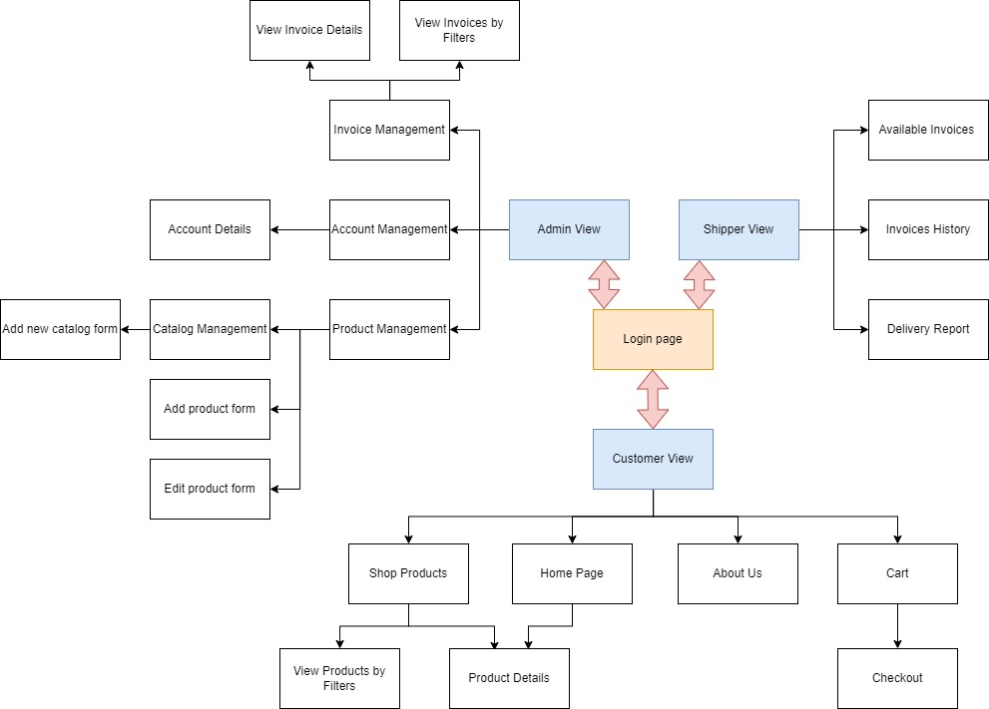

Figure 44: Application interface diagram

### 4.4.1. Customer view

#### 4.4.1.1. Login page

Figure 45: Login page

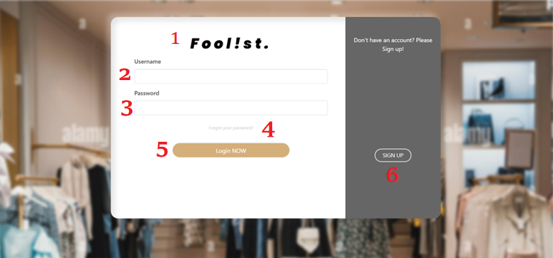

Table 38: Login page explanation table

|  |  |  |
| --- | --- | --- |
| Order | Type | Meaning |
| 1 | Fool!st | Logo of shop |
| 2 | Username textbox | For users to sign username |
| 3 | Password textbox | For users to sign password |
| 4 | Forgot your password? link | After clicking, the page will go to Forgot Password Page |
| 5 | Login NOW button | After clicking, the page will go to Home Page |
| 6 | SIGN UP button | After clicking, the page will go to Register Page |

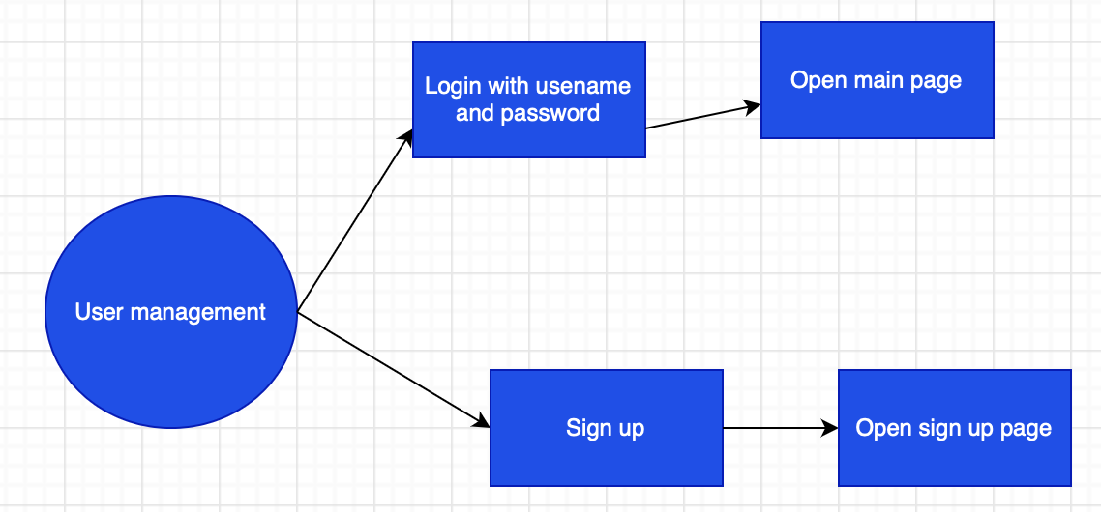

Figure 46: Login page flow

#### 4.4.1.2. Register page

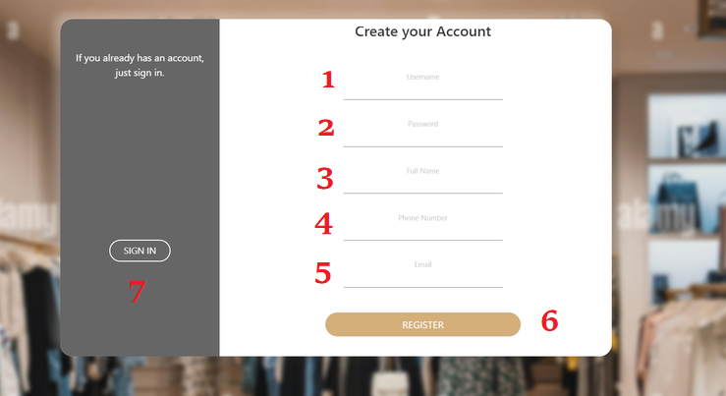

Figure 47: Register page

Table 39: Register page explanation table

|  |  |  |
| --- | --- | --- |
| Order | Type | Meaning |
| 1 | Username textbox | For users to sign username |
| 2 | Password textbox | For users to sign password |
| 3 | Fullname textbox | For users to sign fullname |
| 4 | Phone Number textbox | For users to sign phone number |
| 5 | Email textbox | For users to sign email address |
| 6 | REGISTER button | After clicking, the page will go to Login Page |
| 7 | SIGN IN button | After clicking, the page will go to Login Page |

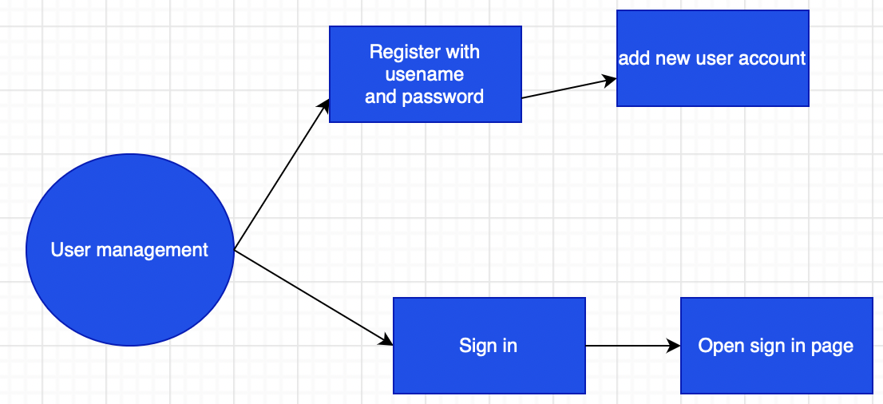

Figure 48: Register page flow

#### 4.4.1.3. Home page

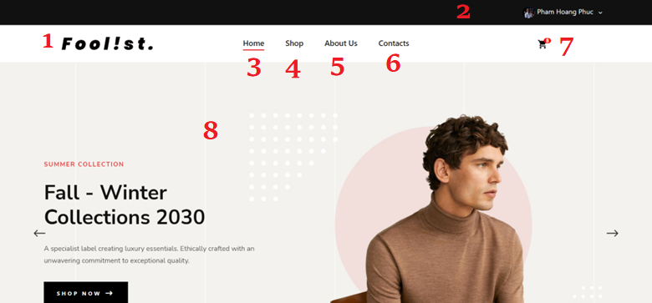

Figure 49: Home page

Table 40: Home page explanation table

|  |  |  |
| --- | --- | --- |
| Order | Type | Meaning |
| 1 | Fool!st | Logo of shop |
| 2 | Header | Show the header of website |
| 3 | Home Menu | After clicking, the page will go to Home Page |
| 4 | Shop Menu | After clicking, the page will go to Shop products Page |
| 5 | About Us Menu | After clicking, the page will go to About Us Page |
| 6 | Contacts Menu | After clicking, the page will go to Contacts Page |
| 7 | Card button | After clicking, the page will go to Cart Page |
| 8 | Banner slider | Show the slider of banner |

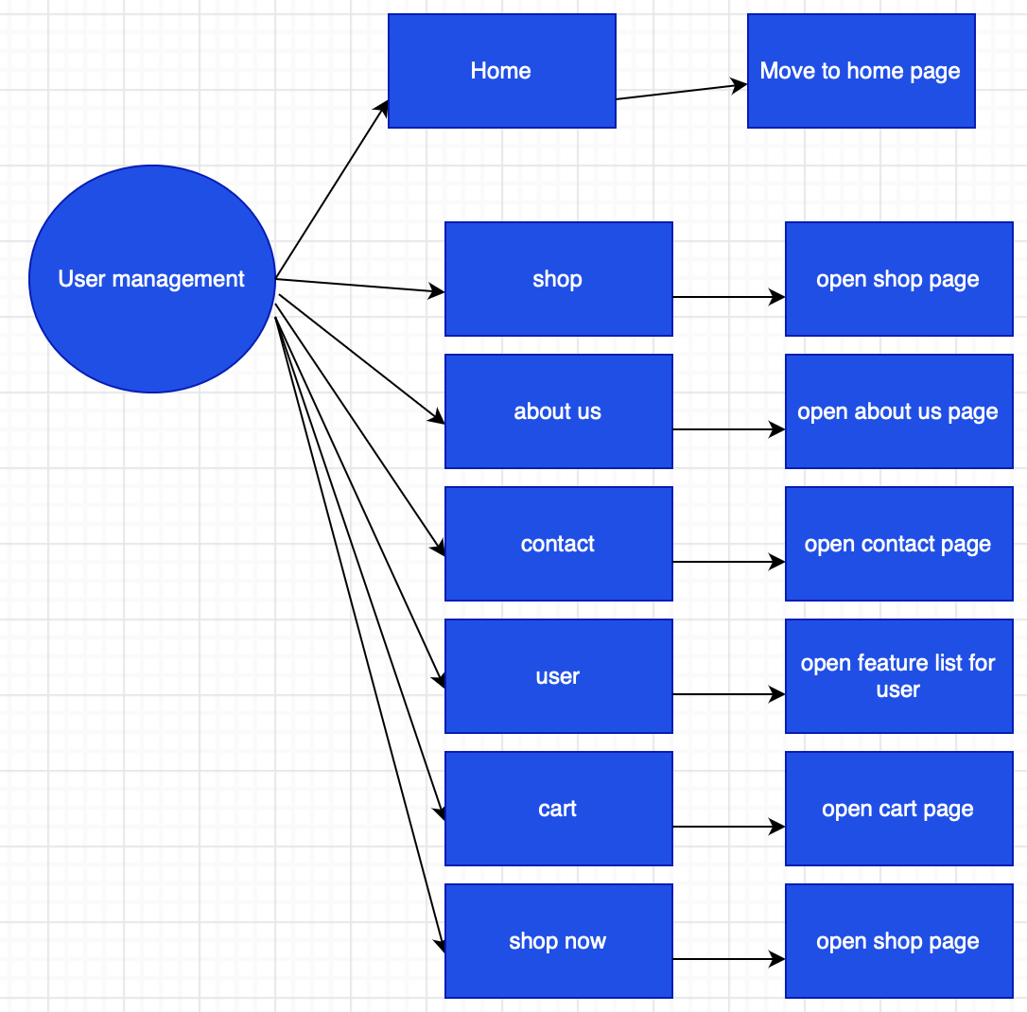

Figure 50: Home page flow

#### 4.4.1.4. Shop products page

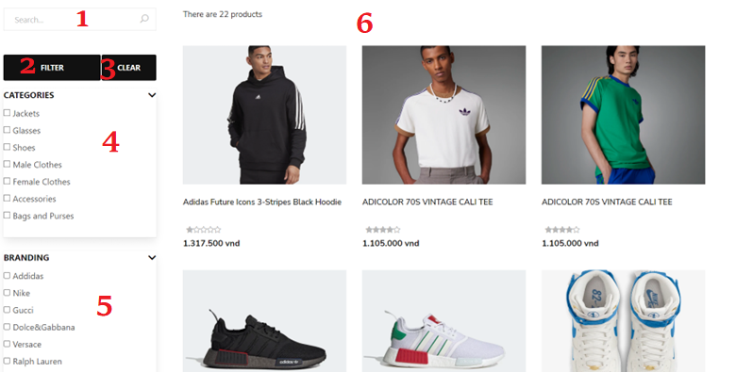

Figure 51: Shop products page

Table 41: Shop products page explanation table

|  |  |  |
| --- | --- | --- |
| Order | Type | Meaning |
| 1 | Search textbox | For users to sign information want to search |
| 2 | Filter button | After clicking, the page will show the products according filter |
| 3 | Clear button | After clicking, the page will clear all the filter |
| 4 | List of Categories checkbox | For users to choose the filter according categories |
| 5 | List of Branding checkbox | For users to choose the filter according branding |
| 6 | List of Product | Show all products or products according filter |

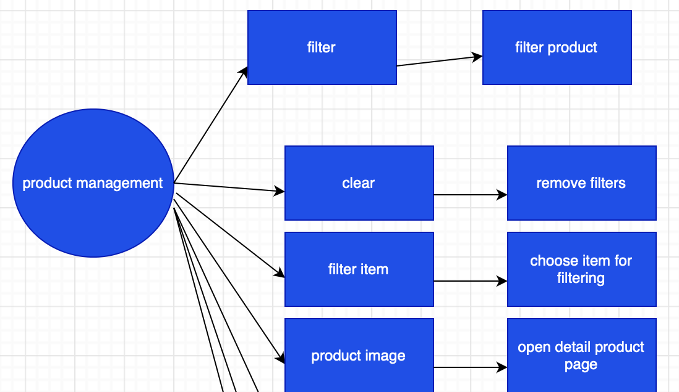

Figure 52: Shop products page flow

#### 4.4.1.5. Shop details

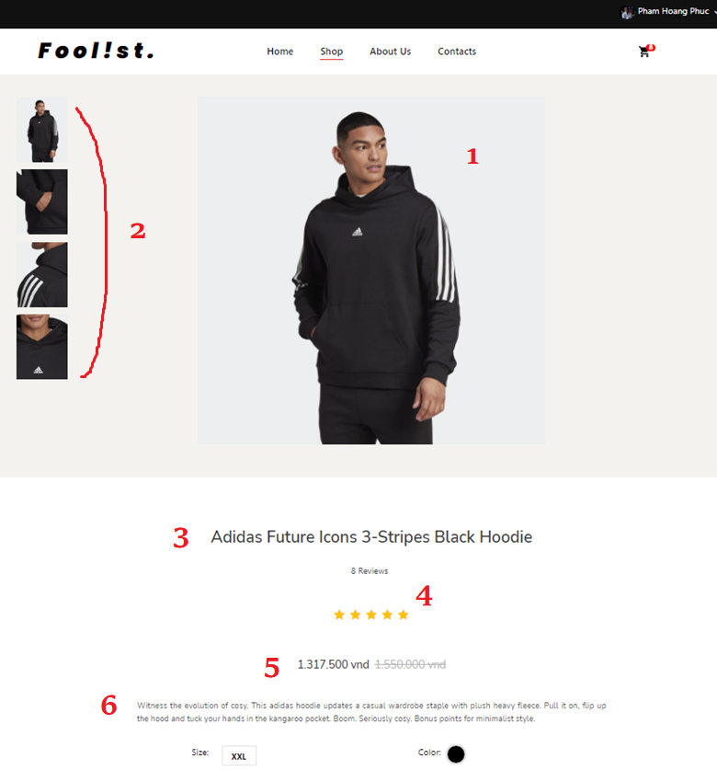

Figure 53: Shop details

Table 42: Shop details explanation table

|  |  |  |
| --- | --- | --- |
| Order | Type | Meaning |
| 1 | Product Image | Show the product image |
| 2 | List of Product Images | For users to choose the product image want to see |
| 3 | Product Name | Show the product name |
| 4 | Rating of Product | Show the rating of that product |
| 5 | Price of Product | Show the price of that product |
| 6 | Description of Product | Show the description of that product |

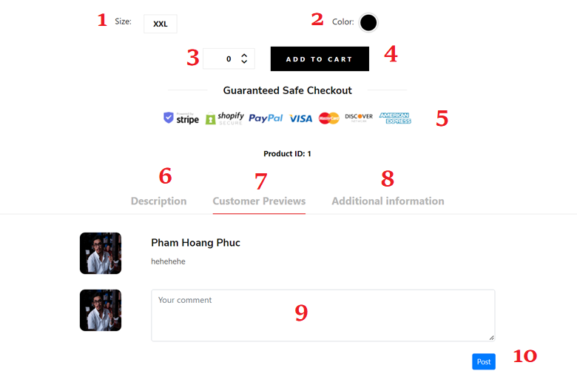

Figure 54: Shop details

Table 43: Shop details explanation table

|  |  |  |
| --- | --- | --- |
| Order | Type | Meaning |
| 1 | Size text | Show the available size |
| 2 | Color radio button | Show the color size |
| 3 | Quantity select box | For users to choose the quantity want to buy |
| 4 | ADD TO CART button | After clicking, the page will go to Cart Page |
| 5 | Logo of payment type | Show the logo of payment type |
| 6 | Description Tab | After clicking, the page will show the description of product |
| 7 | Customer Previews Tab | After clicking, the page will show the customer reviews about product |
| 8 | Additional information Tab | After clicking, the page will show the additional information of product |
| 9 | Comment textbox | For users to comment about product |
| 10 | Post button | After clicking, the page will show the comment that users signed |

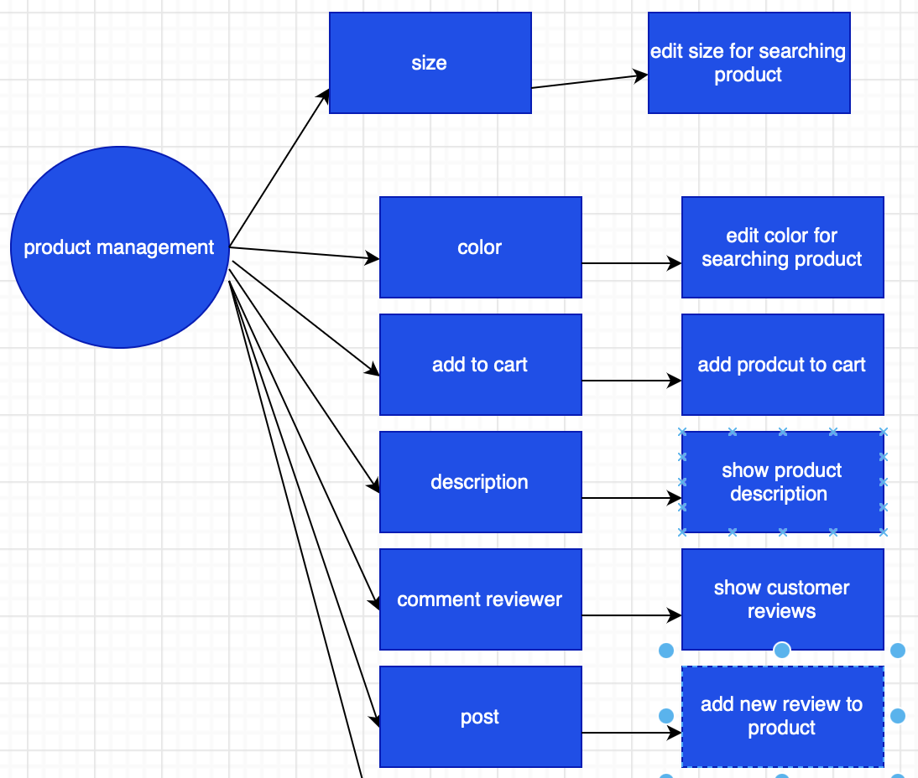

Figure 55: Shop details flow

#### 4.4.1.6. Cart

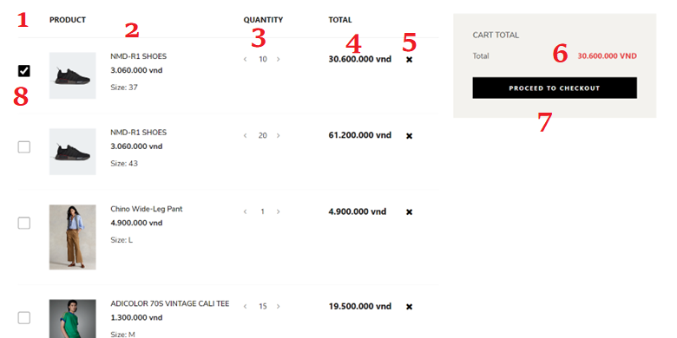

Figure 56: Cart

Table 44: Cart explanation table

|  |  |  |
| --- | --- | --- |
| Order | Type | Meaning |
| 1 | Product Image | Show the product image |
| 2 | Product Name | Show the product name |
| 3 | Product Quantity | Show the product quantity |
| 4 | Total price | Show the total price of product |
| 5 | Delete button | After clicking, the page will remove that product from cart |
| 6 | Total price | Show the total price of product |
| 7 | PROCEED TO CHECKOUT button | After clicking, the page will show the customer reviews about product |
| 8 | Check box | For user choose the product want to payment |

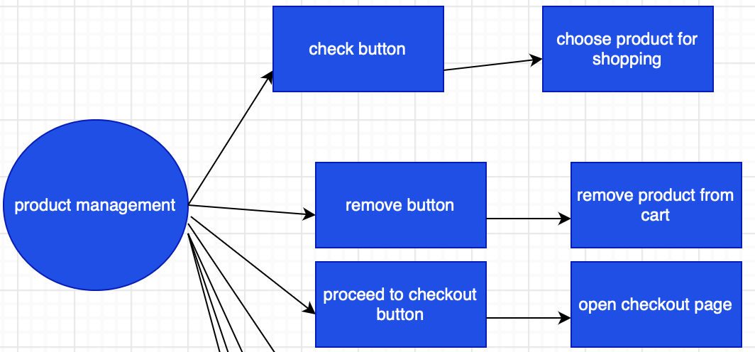

Figure 57: Cart flow

#### 4.4.1.7. Checkout

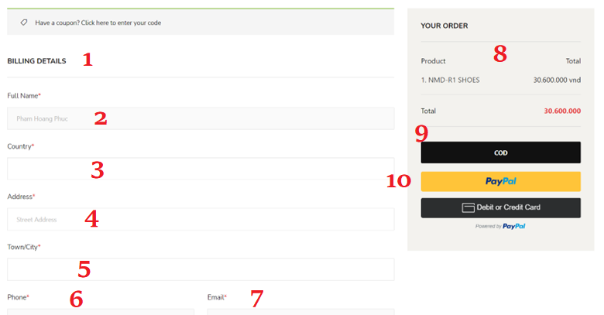

Figure 58: Checkout

Table 45: Check out explanation table

|  |  |  |
| --- | --- | --- |
| Order | Type | Meaning |
| 1 | BILLING DETAILS | Show the information that users need sign |
| 2 | Fullname textbox | For users to sign full name |
| 3 | Country textbox | For users to sign country |
| 4 | Address textbox | For users to sign address |
| 5 | Town/City textbox | For users to sign town/city |
| 6 | Phone textbox | For users to sign phone number |
| 7 | Email textbox | For users to sign email address |
| 8 | Bill information | Show the product name and total price |
| 9 | COD button | After clicking, this invoice will be set to wait for admin acceptance |
| 10 | PayPal button | After clicking, this button will show Paypal UI to make payment directly |

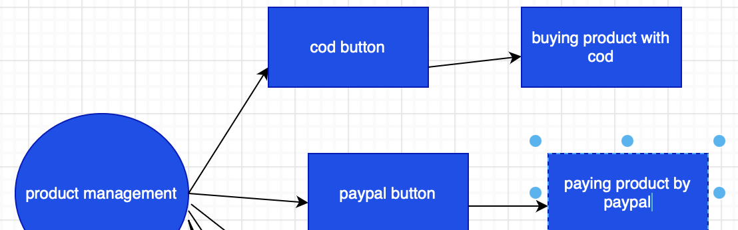

Figure 59: Checkout flow

#### 4.4.1.8. Profile

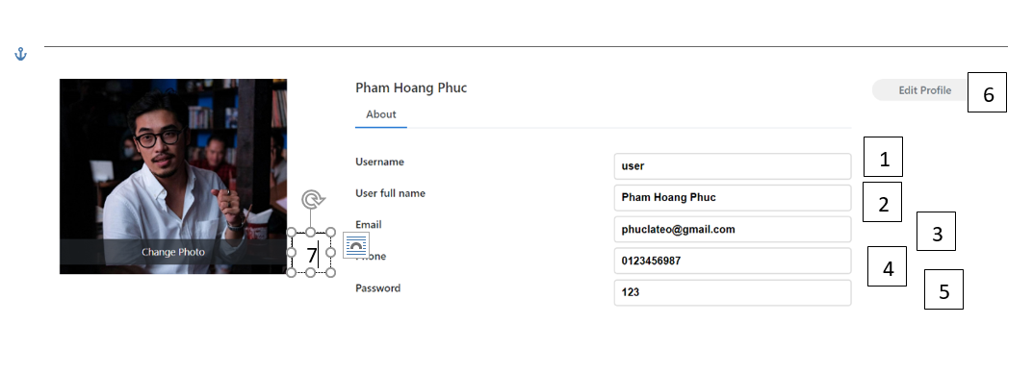

Figure 60: Profile

Table 46: Profile explanation table

|  |  |  |
| --- | --- | --- |
| Order | Type | Meaning |
| 1 | UserName textbox | show username of user |
| 2 | Fullname textbox | Show the user name |
| 3 | Email textbox | Show the user email |
| 4 | Phone textbox | Show the user phone |
| 5 | Password textbox | Show the user password |
| 6 | Edit button | Edit user information |
| 7 | Change photo button | Edit user photo |

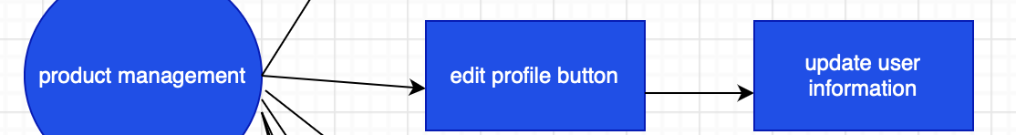

Figure 61: Profile flow

#### 4.4.1.9. Purchase history

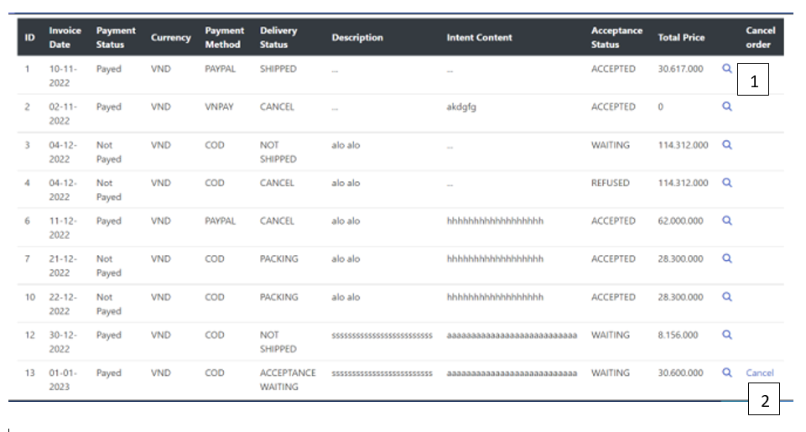

Figure 62: Purchase history

Table 47: Purchase history table

|  |  |  |
| --- | --- | --- |
| Order | Type | Meaning |
| 1 | View detail button | View invoice details button |
| 2 | Cancel button | Cancel order |

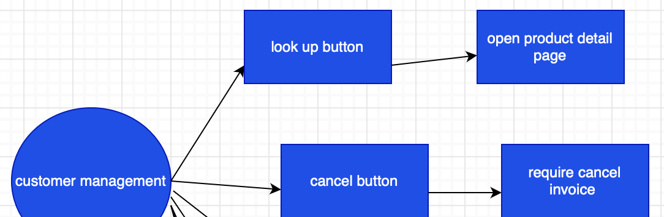

Figure 63: Purchase history flow

### 4.4.2. Shipper view

#### 4.4.2.1. Available invoices

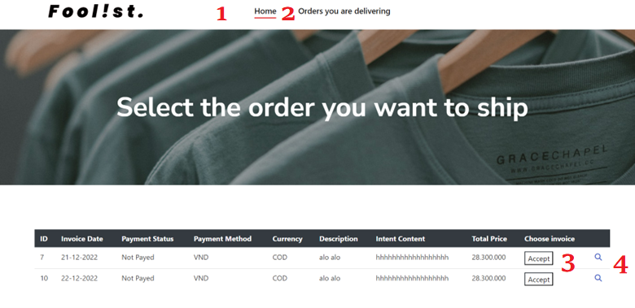

Figure 64: Available invoices

Table 48: Available invoices explanation table

|  |  |  |
| --- | --- | --- |
| Order | Type | Meaning |
| 1 | Button | Go to delivery home page |
| 2 | Button | Go to delivering order page |
| 3 | Button | Accept order to delivering |
| 4 | Button | Open order detail page |

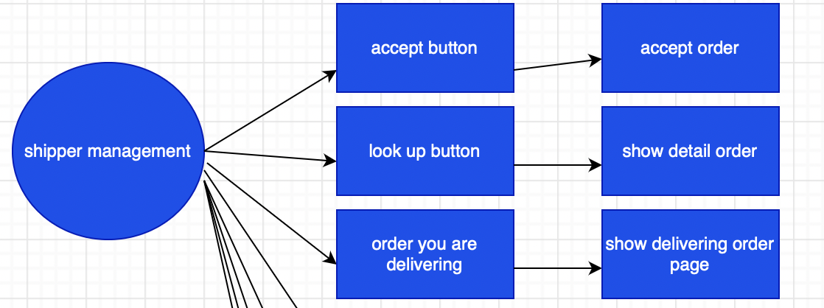

Figure 65: Available invoices flow

#### 4.4.2.2. Shipping invoices

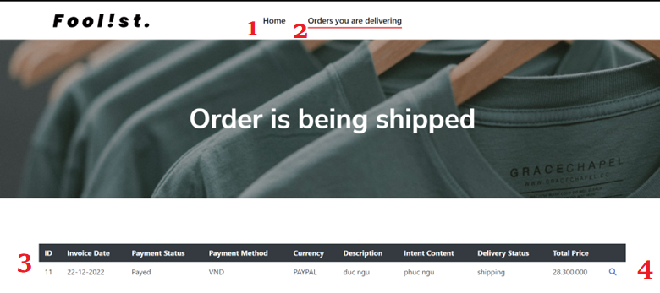

Figure 66: Shipping invoices

Table 49: Shipping invoices explanation table

|  |  |  |
| --- | --- | --- |
| Order | Type | Meaning |
| 1 | Button | Go to delivery home page |
| 2 | Button | Go to delivering order page |
| 3 | Table | Show order list |
| 4 | Button | Open order detail page |

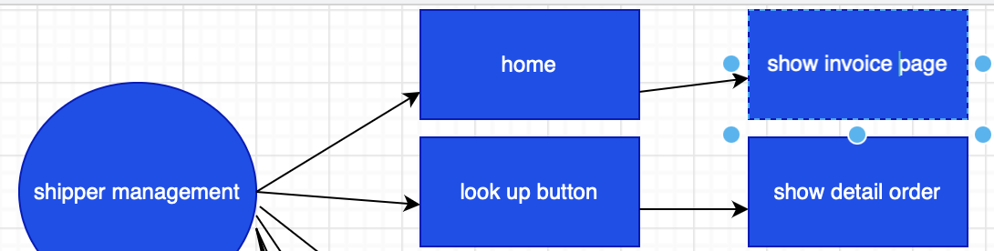

Figure 67: Shipping invoices flow

#### 4.4.2.3. Delivery report

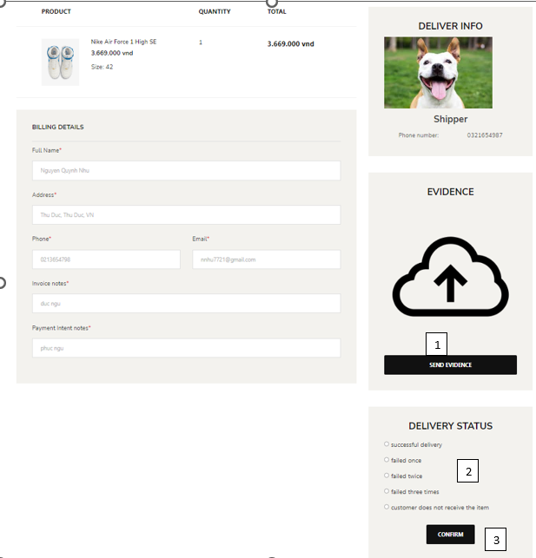

Figure 68: Delivery report

Table 50: Delivery report explanation table

|  |  |  |
| --- | --- | --- |
| Order | Type | Meaning |
| 1 | Button | Send evidence image |
| 2 | Radio | Check delivery status |
| 3 | Button | Send status to DB |

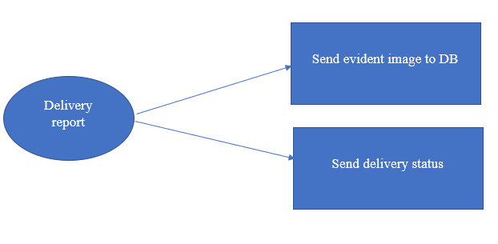

Figure 69: Delivery report flow

### 4.4.3. Admin view

#### 4.4.3.1. Products Management

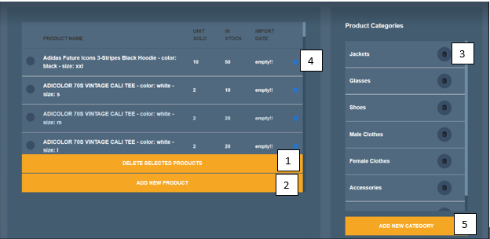

Figure 70: Products Management

Table 51: Products Management explanation table

|  |  |  |
| --- | --- | --- |
| Order | Type | Meaning |
| 1 | Delete selected products button | Delete ticked products |
| 2 | Add new product | Open add product page |
| 3 | Trash button | Remove category |
| 4 | Edit button | Open edit product page |
| 5 | Add new category button | Pop up a dialog to input new category name |

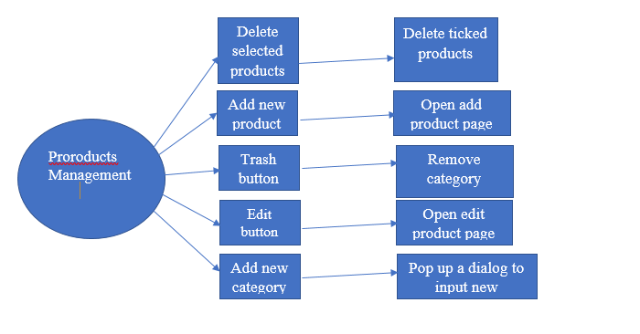

Figure 71: Products Management flow

#### 4.4.3.2. Edit product

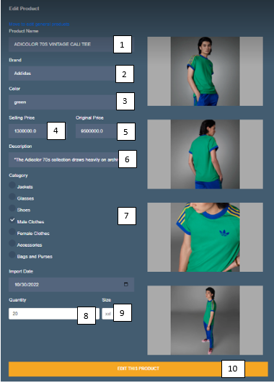

Figure 72: Edit product

Table 52: Edit product explanation table

|  |  |  |
| --- | --- | --- |
| Order | Type | Meaning |
| 1 | Product name text box | Show and edit product name |
| 2 | Product brand text box | Show and edit brand |
| 3 | Product color text box | Show and edit color |
| 4 | Product selling price text box | Show and edit selling price |
| 5 | Product original price text box | Show and edit original price |
| 6 | Product description text box | Show and edit description |
| 7 | Product category check boxes | Show and choose category for product |
| 8 | Product image URL text box | Show and edit image URL |
| 9 | Edit button | Confirm edit product |

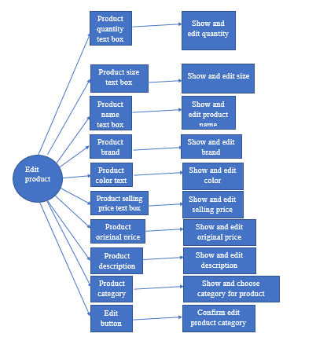

Figure 73: Edit product

#### 4.4.3.3. Add product

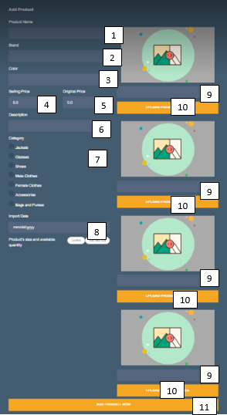

Figure 74: Add product

Table 53: Add product explanation table

|  |  |  |
| --- | --- | --- |
| Order | Type | Meaning |
| 1 | Product name text box | Input product name |
| 2 | Product brand text box | Input brand |
| 3 | Product color text box | Input color |
| 4 | Product selling price text box | Input selling price |
| 5 | Product original price text box | Input original price |
| 6 | Product description text box | Input description |
| 7 | Product category check boxes | Choose category for product |
| 8 | Product quantity text box | Input quantity |
| 9 | Product size text box | Input size |
| 10 | Show image from URL button | Show image from URL |
| 11 | Add button | Confirm add product |

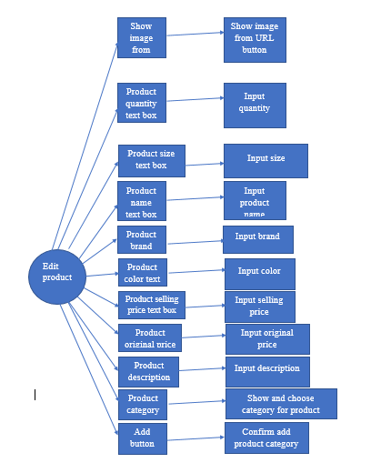

Figure 75: Add product flow

#### 4.4.3.4. Account Management

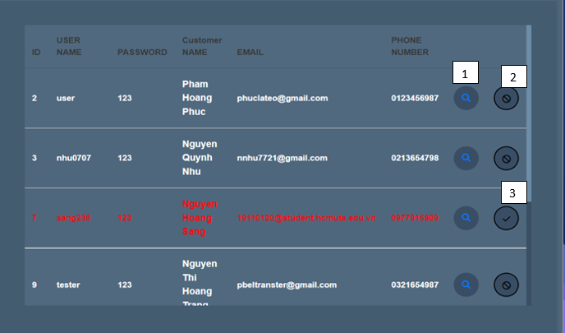

Figure 76: Account Management

Table 54: Account Management explanation table

|  |  |  |
| --- | --- | --- |
| Order | Type | Meaning |
| 1 | Show account details button | Open account details page |
| 2 | Ban button | Ban account |
| 3 | Allow button | Allow account |

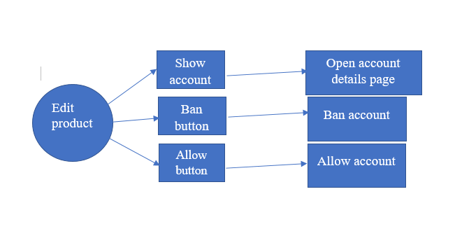

Figure 77: Account Management flow

#### 4.4.3.5. Invoice Management

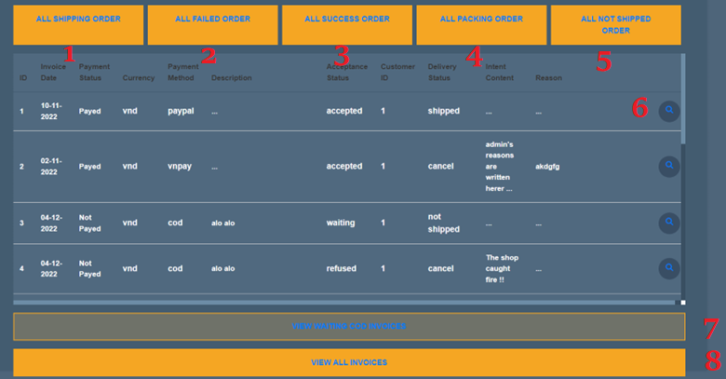

Figure 78: Invoice Management

Table 55: Invoice Management explanation table

|  |  |  |
| --- | --- | --- |
| Order | Type | Meaning |
| 1 | All shipped order button | Filter shipped invoices |
| 2 | All failed order button | Filter failed invoices |
| 3 | All success order button | Filter success invoices |
| 4 | All packing order button | Filter packing invoices |
| 5 | All not shipped order button | Filter shipnot shipped orders |
| 6 | View invoice details | Open invoice details page |
| 7 | View waiting COD invoices | Filter waiting COD invoices |
| 8 | View all invoices | View all invoices |

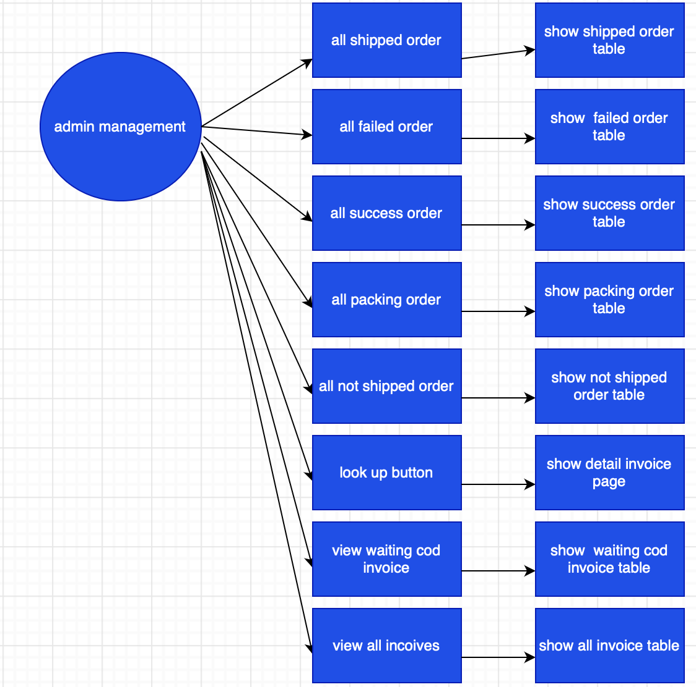

Figure 79: Invoice Management flow

# Chapter 5: Implementation

## 5.1. Setup environment for project

First, we use eclipse IDE to pull project from GitLab



Figure 80: Eclipse

After pulling this project's source code, you must download and set up Spring Boot environment on Eclipse, it will automatically generate a Tomcat server along with other useful operations that can help this project run well



Figure 81: Tomcat

Then you download Thymeleaf package on Eclipse, it will be set up by pom.xml file which contains all dependencies of the MAVEN project



Figure 82: Thymeleaf

Then we run database script at MySQL to generate the database because Spring Boot connects to the database through a driver. Hence, without a database, all source code has no use at all



Figure 83: My SQL

We must edit the valid database login username and password for driver to get access to database, or maybe the port we want localhost to run on at application.properties and persistence.xml file in “resources” folder

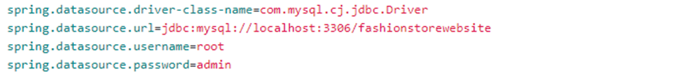

Figure 84: Edit username and password mySQL

In particular, on the above figure, we must change the value of spring.datasource.username and spring.datasource.password in application.properties to the valid value from user name and password that you use to login at MySQL

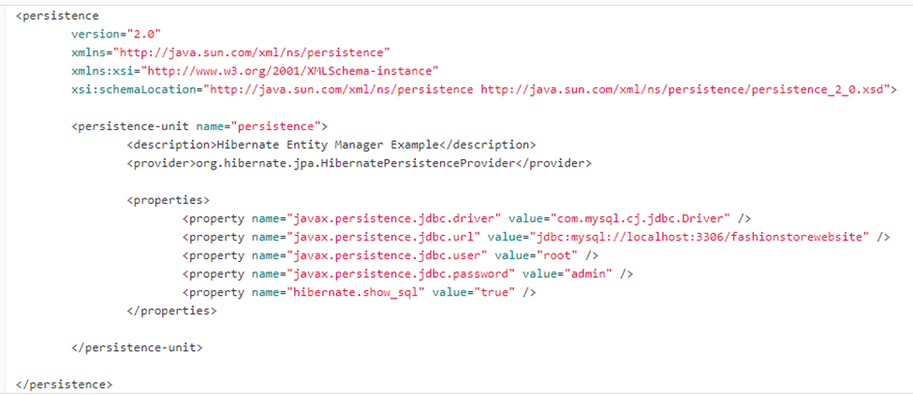

Figure 85: Presistence

Similar to application.properties, we also change user name and password at persistence.xml file at javax.persistence.jdbc.user and javax.persistence.jdbc.password

After all, we start server to run the website

## 5.2. Project file structure

### 5.2.1. Back-end file structure

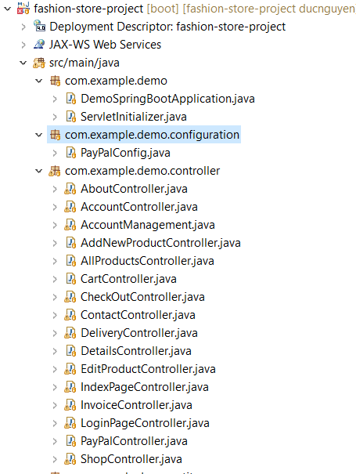

Figure 86: Back-end file structure

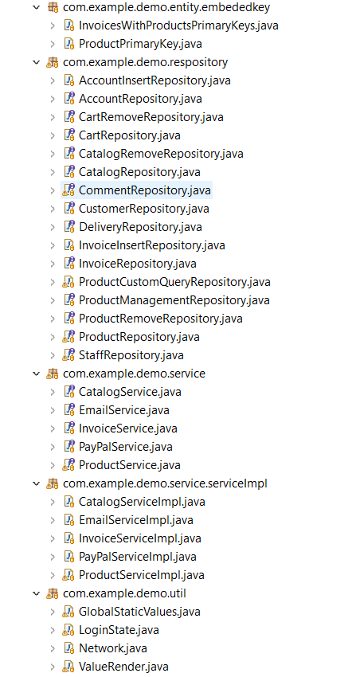

Figure 87: Back-end file structure

### 5.2.2. Front-end file structure

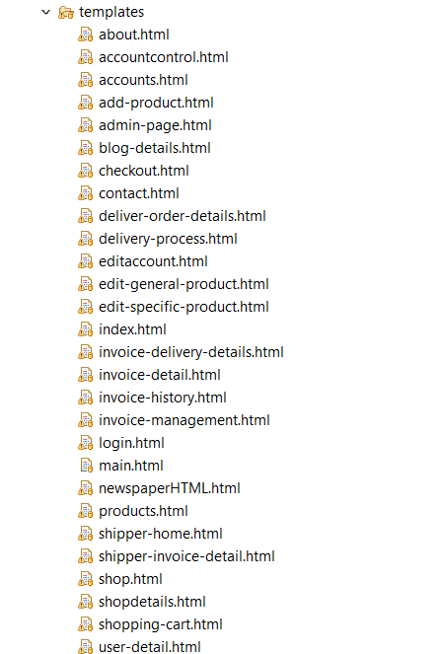

Figure 88: Front-end file structure

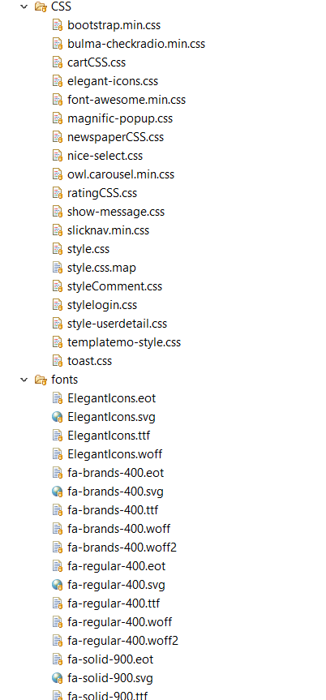

Figure 89: Front-end file structure

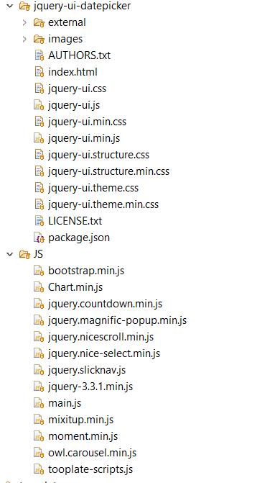

Figure 90: Front-end file structure

# Chapter 6: Software Testing

Table 56: Testcase table

|  |  |  |  |  |  |
| --- | --- | --- | --- | --- | --- |
| ID | Description | Test Steps | Test Data | Actual Result | Status |
| TC_01 | Log in with a valid account | - Enter username and password  - Click Login | Username: user  Password: 123 | As Expected | Pass |
| TC_02 | Log in with an account that doesn't exist | - Enter username and password  - Click Login | Username: abc  Password: 123456 | As Expected | Pass |
| TC_03 | Login with wrong email or password | - Enter username and password  - Click Login | Username: abcd  Password: 123 | As Expected | Pass |
| TC_04 | Register with valid information | -Enter username password and confirm  - Click Register | Username: ducnguyen123  Password: 123456  Confirm: 123456 | As Expected | Pass |
| TC_05 | Register with an existing email account | - Enter email, password and confirm  - Click Register | Username: user  Password: 123456  Confirm: 123456 | As Expected | Pass |
| TC_06 | Register with a password that doesn't match | - Enter email, password and confirm  - Click Register | Username: ducnguyen123  Password: 123456  Confirm: 123 | As Expected | Pass |
| TC_07 | Forgot password with valid email | - Enter username  - Click Forgot password | Username: user1 | As Expected | Pass |
| TC_08 | Search product | - Enter name of product  - Click search | Search: shirt | As Expected | Pass |
| TC_09 | Filter product | - Click Shop  - Select category, branding, price | Select jacket, Addidas | As Expected | Pass |
| TC_10 | Filter products with bestsellers | Home page |  | As Expected | Pass |
| TC_11 | Product details | - Click to product  - Click icon magnifying glass in product image to show detail |  | As Expected | Pass |
| TC_12 | Product details with add to cart button | - Click to product  - Click Add to cart |  | As Expected | Pass |
| TC_13 | Product details with rating product | - Click to product  - Click stars rating  - Click confirm to rating |  | As Expected | Pass |
| TC_14 | Product details with comment | - Click to course  - Click comment |  | As Expected | Pass |
| TC_15 | Cart with remove product from cart | - Click cart  - Click Remove to delete product in cart | Select product want remove | As Expected | Pass |
| TC_16 | Cart update total product | - Click cart  - Check product you want to checkout  - Click update |  | As Expected | Pass |
| TC_17 | Checkout with paypal | - Click checkout  - Fill all information  - Select paypal payment | Login paypal account | As Expected | Pass |
| TC_18 | COD checkout | - Click checkout  - Fill all information  - Select COD |  | As Expected | Pass |
| TC_19 | Product management | - Login with admin  - Click product |  | As Expected | Pass |
| TC_20 | Add product | - Login with admin  - Click product  - Click add product  - Fill all product information  - Click add product now |  | As Expected | Pass |
| TC_21 | Ban user | - Login with admin  - Click User  - Click ban icon |  | As Expected | Pass |
| TC_22 | Edit product | - Login with admin  - Click product  - Click edit product  - Change product information  - Click edit |  | As Expected | Pass |
| TC_23 | Delete product | - Login with admin  - Click Product  - Click delete |  | As Expected | Pass |
| TC_24 | Invoice management | - Login with admin  - Click invoice management |  | As Expected | Pass |
| TC_25 | Invoice management show detail | - Login with admin  - Click invoice management  - Click magnifying glass icon |  | As Expected | Pass |
| TC_26 | Invoice management acceptance | - Login with admin  - Click invoice management  - Click view waiting COD invoice  - Click icon accept or cancel |  | As Expected | Pass |
| TC_27 | Invoice management filter | - Login with admin  - Click invoice management  - Choose button filter to filter invoice |  | As Expected | Pass |
| TC_28 | User edit profile | - Login with user account  - Choose my profile  - Change information you want to edit  - Choose edit profile |  | As Expected | Pass |
| TC_29 | User view purchase history | - Login with user account  - Choose purchase history |  | As Expected | Pass |
| TC_30 | User cancel order | - Login with user account  - Choose purchase history  - Choose cancel order you want |  | As Expected | Pass |
| TC_31 | Delivery selection order | - Login with shipper account  - Choose order you want to delivery  - Click accept button |  | As Expected | Pass |
| TC_32 | Delivery show order are delivering | - Login with shipper account  - Choose orders you are delivering |  | As Expected | Pass |
| TC_33 | Delivery update order are delivering | - Login with shipper account  - Choose orders you are delivering  - Click magnifying glass icon  - Send image evident  - Choose delivery status  - Click confirm button |  | As Expected | Pass |

# Chapter 7: Conclusion

After spending a lot of hard work with enthusiasm, our group has completed this project quite well. We could make all basic operations of an e-commerce website work great in spite of some logical conflicts or struggling in handling complex operations. In addition, our group has also improved teamwork skills which can help us cooperate with each other more smoothly in the future projects.

Through this project, we had lots of chances to learn new knowledge about a really famous JAVA framework - Spring Boot, and how to use Thymeleaf to render data from back-end to user interface

Besides the results that have been achieved, this website still has many things to overcome and improve with many development directions.

## 7.1. Achievements

* Know the theory of Spring boot, mySql, thymeleaf. Learn how to build front-end websites and build databases and connect them.
* Gain effective teamwork skills. Logical thinking is also significantly improved. Know how to start a project effectively and divide the work evenly among team members.
* Project: Fashion shop ecommerce website with all functions that work well. Including three user types (administrator, delivery guy, user). Payment gateway diversity. Beautiful interface and easy to use, simple and fast form of payment

## 7.2. Strengths and drawbacks

The website is designed with an easy-to-see and user-friendly interface. The website is designed with an easy-to-see and user-friendly interface. In particular, simple operations and functions make users feel comfortable while using the website. Customers can buy clothes, accessories easily, can view purchase history and cancel orders and show freedom of speech about product quality directly on the website which may help the owner know what the customers really have in mind about the product.

On the other hand, there are still many shortcomings in the design which makes the application not look optimized in components arrangement. Moreover, the application is suitable for certain screen types because its responsive design is not so optimized and well-prepared. In terms of functions, due to the lack of expertise and experience, the handling logic and performance are not optimal.

## 7.3. Reflection

After completing this website, we feel how small we are in this huge technology world, there are enormous things to learn, to fulfill and to archive in the future. We could also understand more how hard it is to build just a basic e-commerce website, which we thought would be quite easy in the past. Overall, this project has enlightened us about how big this IT world is and will be in the future.

Table 57: Task distribution

|  |  |  |  |
| --- | --- | --- | --- |
| ID | Student name | Task | Percentage |
| 19110147 | Phạm Hoàng Phúc | Design database, usecase, workflow, test project, write report | 100% |
| 19110120 | Nguyễn Hoàng Sang | Back-end programing, test project, write report | 100% |
| 19110118 | Nguyễn Anh Đức | Design UI, Front-end programing, test project, write report | 100% |

## 7.4. Future developments

* Responsive Website.
* Create mobile version
* Improve website performance.
* The team will work to improve the application and add more features in the future.
* Enhance the user interface and experience.

# References

Walls, C. (2015). *Spring Boot in action*. Simon and Schuster.

DuBois, P. (2008). *MySQL*. Pearson Education.

Bibeault, B., De Rosa, A., & Katz, Y. (2015). *jQuery in Action*. Simon and Schuster.

Taming Thymeleaf: Practical guide to building a webapplication with Spring Boot and Thymeleaf by Wim Deblauwe (Author)